Software Engineering Department
Braude College
Capstone Project Phase B
25-1-R-21
VisoSpeak
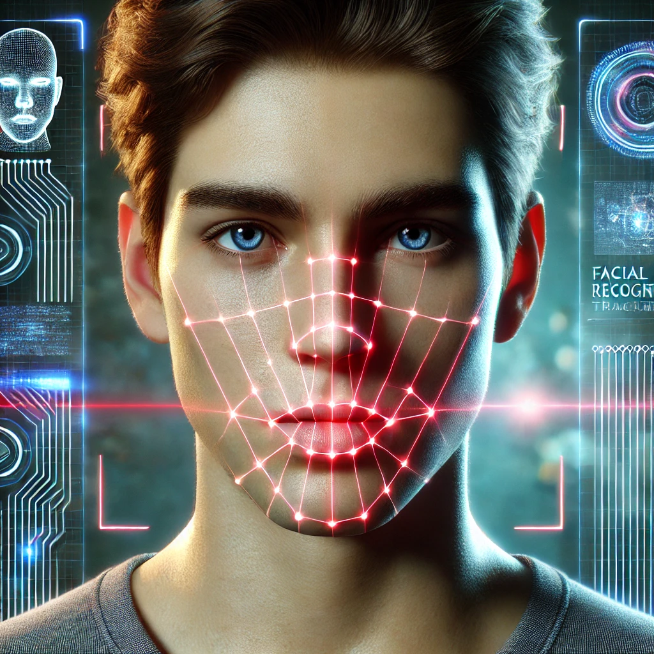

Students:
Morad Asakli, Morad.Asakli@e.braude.ac.il
Majd Salameh, Majd.Salameh@e.braude.ac.il
Supervisor:
Mr. Ilya Zeldner, IlyaZ@braude.ac.il
GITHUB
Contents
1 Abstract 5
2 Introduction 5
2.1 Planned Solution 6
2.2 Benefits 6
3 Related Work and Background 7
3.1 Existing Projects 8
3.2 Existing Tools 8
3.3 Visual Speech Recognition in Video 11
3.3.1 Deep Learning for Visual Speech Recognition 11
3.3.2 Speaker and Condition Variability in Visual Speech Recognition 12
3.4 Current Uses of Visual Speech Recognition 13
4 Research / Engineering Process 13
4.1 Development methods 13
4.1.1 Python 14
4.1.2 TensorFlow and PyTorch 14
4.1.3 OpenCV and Dlib 14
4.1.4 NumPy and Matplotlib 14
4.1.5 Google Colab + Google Drive 14
4.1.6 JiWER 14
4.1.7 GPT 4 MINI API 15
4.2 Choosing Mouth Detection Method 15
4.3 Image Processing Formats: Color vs. Grayscale in Visual Speech Recognition 17
4.3.1 Grayscale Empirical Performance Evidence 17
4.4 Normalization in Preprocessing 20
4.4.1 What Is Normalization? 21
4.4.2 Normalization in LipNet and VisoSpeak 21
4.4.3 Why Normalization Is Beneficial 21
4.4.4 Impact in Our Project 22
5 Algorithm 22
5.1 Algorithm Workflow 22
5.1.1 Final Output 24
5.2 LipNet Model Architecture 24
5.2.1 Input : sequence of mouth frames 25
5.2.2 STCNN + Spatial Pooling 25
5.2.3 GRU 27
5.2.4 Linear Layer and Softmax 28
5.2.5 CTC Loss and Decoding 28
5.2.6 LipNet Results 29
5.3 Transformer-Based Model Architecture 30
5.3.1 Visual Frontend: 3D-CNN 31
5.3.2 Transformer Encoder 32
5.3.3 Transformer Decoder 32
5.3.4 Full Lip Reading Model (Sequential Integration) 33
5.3.5 Data Loading from Google Drive and Preparing Tensors 34
5.3.6 Buffer Strategy for Efficient Training 34
5.3.7 Training Loop 35
5.3.8 Validation 35
5.3.9 Early Stoping 36
5.4 Transformer Comparison: Original vs. Proposed Approach 37
5.4.1 Input Video 37
5.4.2 Preprocessing 37
5.4.3 Feature Extraction (Visual Frontend) 38
5.4.4 Transformer Encoder and Decoder 38
5.4.5 Viseme Set and Structural Tokens 38
5.4.6 Viseme-to-Word Mapping 39
5.4.7 Sentence Construction 39
5.4.8 Future Enhancements 39
5.4.9 Summary Comparison Table 39
5.4.10 Boundary and Viseme Accuracy 40
6 Data Availability 43
6.1 GRID Alignment File Example 43
6.2 LRS2 Alignment File Example 44
7 Work Artifacts 45
7.1 System Flow 45
7.2 FR & NFR Requirements 45
7.2.1 Working Progress 47
7.3 UseCase 48
7.3.1 User UseCase 48
7.3.2 Training UseCase 49
7.4 User Interface 50
7.4.1 Home Screen 50
7.4.2 LipNet Interface 52
7.4.3 Transformer Based Model Interface 53
8 Testing Plan 53
8.1 Scope 53
8.2 Objectives 53
8.3 Test Cases 54
9 Development/Research Challenges 55
9.1 LRS2 Dataset Access Restrictions 55
9.2 Overwhelming Number of Tools and Frameworks 55
9.3 Lack of Powerful Local GPU Resources 56
9.4 I/O Bottlenecks on Colab 56
10 User Guide 57
10.1 Using the website 57
11 Maintenance Guide 62
11.1 System architecture 62
11.2 System Environment 62
11.3 Software Dependencies 63
11.4 Installation 63
11.5 Model Setup 63
11.6 Dataset 64
11.6.1 Dataset Overview 64
11.6.2 Obtaining LRS2 64
11.6.3 Storage & Preprocessing 64
11.6.4 Additional Notes 64
11.7 Training Pipeline (Colab-Based) 65
11.8 Deployment & Maintenance 66
11.9 Using the Application 67
12 References 67

Abstract
VisoSpeak is a visual-only speech recognition system that reconstructs spoken sentences from lip movements without the use of audio signals. The primary contribution of this work is the development of a Transformer-based architecture designed to improve sentence prediction by explicitly modeling word boundaries and inter-word spacing, a critical factor for enhancing segmentation and overall accuracy. In parallel, the LipNet[3] architecture was reproduced as part of this study to explore alternative visual speech recognition methodologies and gain a broader perspective on potential system improvements, rather than for direct comparison. Additionally, this research discusses the potential integration of modern natural language processing techniques for word filtering and sentence construction, highlighting future directions for achieving more efficient and coherent post-prediction processing. Collectively, these contributions establish a foundation for advancing visual-only speech recognition and underscore the significance of precise boundary detection in improving prediction quality.

Introduction
With the increasing demand for silent communication, privacy, and accessibility, visual-only speech recognition has become a crucial area of research, with applications in domains such as healthcare, education, and assistive technologies [1][2][3]. Traditional systems often struggle in noisy environments or depend on constrained vocabularies, which limits their scalability and robustness [3][6].
This work primarily focuses on the development of a Transformer-based model that reconstructs spoken sentences from lip movements without using audio input. The model introduces enhanced detection of word boundaries and inter-word spacing, which plays a pivotal role in improving segmentation and overall prediction accuracy. In parallel, we reproduced the LipNet architecture—a well-established visual speech recognition model—primarily to explore alternative approaches and gain broader insights into the design of such systems, rather than to perform a direct comparison.
Furthermore, this research discusses the potential integration of modern natural language processing techniques for word filtering and sentence construction, aiming to replace earlier post-processing approaches with more efficient and context-aware methods. These contributions establish a foundation for advancing visual-only speech recognition systems and highlight the importance of precise boundary modeling in achieving improved prediction quality.

Planned Solution
The primary objective of this research is to improve the accuracy of visual-only speech recognition by introducing explicit modeling of word boundaries within continuous lip movement sequences. This is achieved by adding two new structural tokens<sow> (start of word) and <eow> (end of word) to the existing token set (<sos>, <eos>, <space>, <sil>). These tokens allow the Transformer-based model to precisely identify word onsets and endings, leading to more accurate segmentation and improved sentence prediction.
The proposed architecture consists of a 3D-CNN visual frontend followed by Transformer encoder–decoder layers for viseme sequence prediction. By leveraging boundary-aware tokens, the model learns to capture natural word spacing patterns directly during training, reducing reliance on heuristic post-processing.
In addition, this work explores the potential use of modern NLP techniques for post-prediction word filtering and sentence construction. Although not implemented in this phase, these methods are presented as future enhancements to further increase accuracy and efficiency beyond traditional approaches.

Benefits
The VisoSpeak system offers significant advantages across accessibility, education, research, and technology. For individuals with hearing impairments, it provides a communication aid capable of reconstructing spoken sentences from lip movements alone, promoting independence and inclusion in both personal and professional contexts. In educational and noise-sensitive environments—such as classrooms, hospitals, or libraries—the system supports silent visual communication without relying on audio signals.
For researchers and developers, VisoSpeak serves as a flexible framework for advancing visual speech recognition, particularly through its explicit modeling of word boundaries using <sow> and <eow> tokens. This boundary-aware approach improves segmentation and prediction accuracy and can be further extended with modern NLP techniques for more efficient word filtering and sentence construction. Collectively, these contributions provide valuable insights into visual speech patterns and lay the groundwork for future innovations in accessible language processing technologies.

Related Work and Background
Visual speech recognition, also known as lip reading, has gained considerable attention due to its potential in accessibility, silent communication, and speech processing under noisy conditions. Traditional approaches relied on handcrafted features and alignment-based models such as Hidden Markov Models (HMMs), which often failed to capture the complexity of sentence-level visual speech [6]. Recent advances in deep learning have revolutionized this field, introducing models that are trained end-to-end on raw video inputs.
A key breakthrough came with LipNet [3], the first end-to-end model for sentence-level lip reading, which employed spatiotemporal convolutions (3D-CNNs), bidirectional recurrent layers, and Connectionist Temporal Classification (CTC) loss to predict character sequences directly from video. Building on this, Chung et al. introduced the “Lip Reading Sentences in the Wild” framework [1], which tackled real-world visual speech using the WLAS model—a sequence-to-sequence architecture that integrates audio-visual inputs and attention mechanisms.
Further innovation in feature extraction was driven by 3D Convolutional Neural Networks (3D-CNNs), which capture both spatial and temporal features across video frames [5]. These architectures, combined with residual networks such as ResNet [4], allow for more accurate and robust visual feature representation. Meanwhile, improvements in search algorithms like beam search [7][8] and unsupervised pre-training via language models such as GPT [9] have further enhanced the decoding of visual speech into structured text.
Additionally, mapping phonemes to visemes—visual equivalents of spoken sounds—has been a foundational approach in visual speech modeling, as explored by [6]. This abstraction reduces the complexity of visual speech classification and has been integrated into recent models, including our own.
Technologies such as the Single Shot MultiBox Detector (SSD) [10] have proven useful for real-time lip and face detection, enabling robust preprocessing in lip reading systems.
In summary, the field has evolved from static, handcrafted models to dynamic, deep learning–based systems capable of end-to-end sentence recognition. Our project, VisoSpeak, is grounded in this body of work, combining LipNet’s proven effectiveness [3] with newer Transformer-based methods and adaptive segmentation strategies to explore the next frontier in visual speech recognition.

Existing Projects
LipNet (Assael et al., 2016):
LipNet was the first model to demonstrate end-to-end sentence-level lip reading using deep learning. It combines spatiotemporal convolutions (3D-CNN), bidirectional GRUs, and Connectionist Temporal Classification (CTC) loss to map sequences of video frames directly to character-level text [3]. Trained on the GRID dataset, LipNet outperforms experienced human lip readers and earlier word-level models. Its success in capturing temporal dependencies in visual speech makes it a foundational system in modern lip reading research.
Lip Reading Sentences in the Wild (Chung et al., 2017)
This project introduces the "Watch, Listen, Attend, and Spell" (WLAS) model, which processes both visual and audio data to transcribe unconstrained speech from real-world videos [1]. Utilizing curriculum learning, attention mechanisms, and large-scale LRS datasets, the system surpasses prior benchmarks. Though multimodal, its visual recognition capabilities alone set a strong precedent for handling complex, real-world lip reading tasks in noisy or multilingual settings.
Lip Reading Sentences Using Deep Learning (Fenghour et al., 2020)
This study proposes a visual-only lip reading system based on Transformer architecture, focusing on viseme classification and sentence generation using GPT-based perplexity analysis [2]. Trained on the BBC LRS2 dataset, the system is robust to lighting variations, speaker diversity, and complex vocabulary. Its Transformer-based design inspired parts of the VisoSpeak architecture for sequence modeling and viseme decoding.

Existing Tools
Single Shot MultiBox Detector (SSD)
SSD is a deep learning framework used for real-time object detection, including facial and lip region localization [10]. It eliminates the need for region proposals by predicting object positions and class confidences directly from feature maps. In lip reading systems like VisoSpeak, SSD enables fast and accurate mouth region tracking, which is critical for consistent preprocessing across video frames.
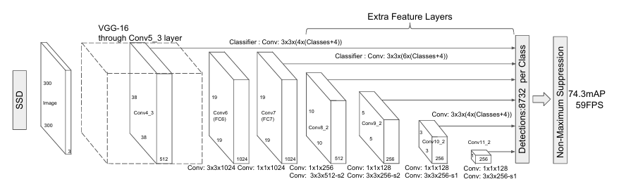
Figure1: SSD architecture
3D Convolutional Neural Networks (3D-CNN)
3D-CNNs extend traditional CNNs by adding a temporal dimension, allowing them to learn from sequences of frames rather than static images [5]. This enables extraction of both spatial and motion features, making them ideal for applications such as action recognition and lip reading. In VisoSpeak, 3D-CNNs are used in the visual frontend to extract spatiotemporal features from the mouth region.
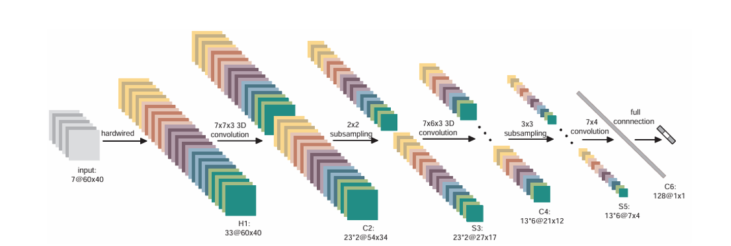
Figure2: 3D-CNN architecture

2D-ResNet
ResNet introduces residual connections that allow training of very deep networks by mitigating the vanishing gradient problem [4]. In VisoSpeak, 2D-ResNet modules help refine feature maps extracted from frames, offering powerful representations for downstream viseme classification. These residual blocks ensure better convergence and performance in deep learning pipelines.
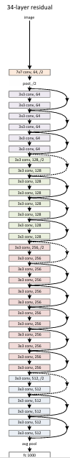
Figure3: 2D-ResNet architecture

Phoneme-to-Viseme Mapping (via HMMs)
Visemes are visual equivalents of phonemes, and mapping between the two has been used to simplify visual speech modeling [6]. HMMs have historically been applied for this conversion by modeling phoneme sequences and translating them into corresponding viseme clusters. In modern systems, this concept is integrated with deep learning classifiers to enhance viseme prediction accuracy.
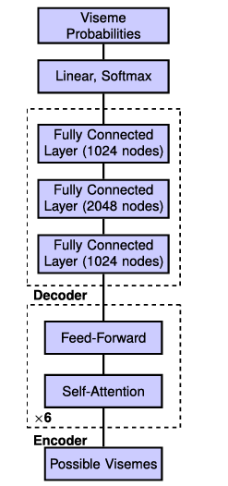
Figure4 : Phoneme-to-Viseme Mapping

Beam Search
Beam Search is a decoding algorithm that maintains multiple candidate sequences at each step, balancing accuracy and efficiency during prediction [7][8]. It is widely used in sequence models, including CTC-based systems like LipNet and Transformer-based models like VisoSpeak. Beam Search ensures that the most probable output sequences are retained without exhaustive computation.
GPT Transformer
The Generative Pre-trained Transformer (GPT) operates through unsupervised pre-training followed by task-specific fine-tuning [9]. While originally designed for NLP, GPT’s language modeling capability has been adapted in visual speech systems to evaluate and score candidate sentence outputs using perplexity analysis. This supports more coherent and grammatically correct predictions from viseme sequences.

Visual Speech Recognition in Video
In the field of computer vision, interpreting spoken language from silent video—commonly known as visual speech recognition (VSR) or lip reading—has become increasingly important in domains such as accessibility, silent communication, and audio-agnostic transcription. This task presents several challenges due to speaker variability, lighting conditions, and the complexity of mapping subtle lip movements to accurate linguistic outputs.
The advent of deep learning has significantly advanced VSR performance, replacing traditional handcrafted approaches with Convolutional Neural Networks (CNNs) and sequence modeling architectures like GRUs and Transformers. CNNs are particularly effective in extracting spatial features from lip regions across frames, while sequence models capture temporal dependencies necessary for understanding complete sentences.
Architectures such as LipNet pioneered the use of 3D-CNNs and bidirectional GRUs with CTC loss for end-to-end sentence prediction, achieving results superior to expert human lip readers [3]. More recent models like Watch, Listen, Attend and Spell (WLAS) and transformer-based frameworks have further improved sentence reconstruction using attention mechanisms and large-scale pretraining [1][2].
However, the field still faces challenges with real-time inference, limited viseme-to-word generalization, and domain adaptation across datasets. Recent research focuses on improving robustness in uncontrolled environments, efficient sequence decoding, and dynamic segmentation methods to better handle varying speaking speeds.
The integration of simulated timing logic, beam search, and token-based decoding in systems like VisoSpeak represents a step toward more adaptive and linguistically accurate visual speech recognition, with wide potential impact in accessibility technologies and silent interface applications.

Deep Learning for Visual Speech Recognition
Visual speech recognition has significantly advanced with the adoption of deep learning, particularly through the use of Convolutional Neural Networks (CNNs) and sequence modeling architectures. Earlier approaches relied heavily on handcrafted visual features such as lip contours or optical flow, which often failed to generalize across different speakers, lighting conditions, or speaking styles. In contrast, deep learning models automatically learn hierarchical representations that are robust to such variations.
In VSR systems, 3D-CNNs are often employed to extract spatiotemporal features from sequences of mouth frames, capturing both appearance and motion. These features are then passed through recurrent layers (such as GRUs or LSTMs) or Transformer encoders, which model temporal dependencies across frames to reconstruct complete sentences. Architectures like LipNet exemplify this structure, combining 3D convolutions with bidirectional GRUs and CTC loss for sequence-level prediction [3].
Such end-to-end deep learning models eliminate the need for manual feature engineering and significantly outperform traditional techniques, making them foundational in modern visual speech systems like VisoSpeak.

Speaker and Condition Variability in Visual Speech Recognition
Just as person identification across camera views requires robust representations invariant to angle or lighting, visual speech recognition faces similar challenges with speaker variability, lip shapes, head poses, and environmental conditions. These variations can significantly affect the accuracy of lip-reading systems.
To address this, modern VSR models aim to learn speaker-independent representations by training on diverse datasets (e.g., GRID, LRS2) and using architectures that can generalize well across accents, speech styles, and facial geometries. 3D-CNNs are particularly effective at capturing consistent lip motion features across frames, even when head poses shift slightly or lighting conditions change.
Transformer-based models, like the one used in VisoSpeak, further improve robustness by leveraging attention mechanisms that can selectively focus on relevant visual cues while ignoring transient noise or irrelevant frames. Additionally, token-level segmentation and simulated timing logic help accommodate differences in speaking pace and style.
In this way, techniques in VSR echo those in cross-view person identification—both seek to maintain performance despite changes in input conditions, ensuring that the model learns stable, transferable features.

Current Uses of Visual Speech Recognition
Visual speech recognition (VSR) systems are increasingly being used across various domains to enhance communication and information extraction in video-based scenarios. In surveillance and security, VSR can support silent or noisy environment monitoring by interpreting speech visually when audio is unavailable or corrupted. It can also assist in law enforcement by analyzing video footage of suspects or victims, allowing for silent speech decoding when lip movements are visible but no sound is recorded.
In healthcare and assistive technology, lip-reading systems offer valuable support to individuals with hearing impairments, providing real-time transcription of conversations in face-to-face or video call settings. This enables better access to communication in schools, hospitals, and public services. In broadcasting and media analysis, VSR technologies can
transcribe and index large volumes of video content, making archives searchable even when audio quality is poor.
Retail and service industries may also leverage lip reading to analyze customer sentiment or intent from visual-only recordings in compliance with privacy regulations. In transportation
and vehicle safety, VSR has potential applications for driver monitoring systems, especially in detecting driver speech commands or distractions in noise-heavy environments.
Overall, the growing integration of VSR tools in silent communication, accessibility, surveillance, and media analytics demonstrates their transformative potential across sectors that depend on video-based interaction. [11][12]

Research / Engineering Process
The VisoSpeak system employs two deep learning architectures for visual-only speech recognition: the LipNet model and a custom Transformer-based model. Both approaches aim to decode full sentences from silent video by analyzing lip movements, but differ in architecture and decoding strategies. Below, we describe the combined algorithmic pipeline, drawing from both models and integrating simulated dynamic segmentation for future adaptability.

Development methods
The VisoSpeak project integrates state-of-the-art deep learning frameworks and supporting tools to implement and analyze visual speech recognition models. The combination of model architectures, preprocessing utilities, and training infrastructure enables an efficient and scalable research environment. Below are the key technologies used:

Python
Python[13] is the core programming language for the entire project, chosen for its flexibility and strong ecosystem in machine learning. It enables integration across preprocessing, model building, training routines, and visualization.

TensorFlow and PyTorch
Both TensorFlow and PyTorch are used in different parts of the project:
- TensorFlow was used to implement and train the LipNet model, leveraging Keras APIs for rapid prototyping.
- PyTorch powered the Transformer-based model, offering dynamic computation graphs and better control over training loops and model debugging.

OpenCV and Dlib
OpenCV is used for video frame extraction, grayscale conversion, resizing, and general preprocessing.
Dlib provides facial landmark detection, crucial for isolating and aligning the mouth region during lip cropping.

NumPy and Matplotlib
These libraries are essential for array manipulation, timing simulations, data preprocessing, and visualizing model outputs (e.g., loss curves, token sequences).

Google Colab + Google Drive
Google Colab provides the compute environment for training and testing, with seamless integration to Google Drive for storing checkpoints, logs, training graphs, and dataset copies. This setup enabled experiment reproducibility and remote access.

JiWER
JiWER (JavaScript Implementation of Word Error Rate) is used for evaluating the accuracy of predicted sentences using WER and CER metrics.

GPT 4 MINI API
GPT-4 Mini API is a lightweight transformer-based language model that evaluates and predicts natural language sequences based on context. In this project, it serves to infer words from viseme sequences and reconstruct coherent sentences by leveraging its understanding of grammar and fluency.

Choosing Mouth Detection Method
Accurate mouth detection is essential for visual-only speech recognition. We evaluated Dlib and MediaPipe Face Mesh as preprocessing methods for lip-region extraction and ultimately chose MediaPipe Face Mesh due to its balance of speed, accuracy, and landmark detail.
Summary of Trial and Selection
- We implemented both Dlib (68-point detector) and MediaPipe Face Mesh (468 landmarks) in our preprocessing pipeline.
- MediaPipe offered significantly higher frame rates (~20 FPS) and produced rich, precise landmarks—even under varied poses and lighting.
- Although Dlib performed slightly faster in some scenarios, it showed reduced landmark accuracy when the mouth was downturned and lacked dense detail around lips.
Based on these results, we adopted MediaPipe Face Mesh for consistent and reliable mouth detection across datasets like GRID and LRS2. [14][15][16]
Feature | Dlib (68-point) | MediaPipe Face Mesh (468 landmarks)
Landmark Count | 68 | 468
Lip Landmark Precision | Less detailed; poorly handles downturned expressions | Dense and robust around lips
Detection Speed | ~6 FPS | ~18–20 FPS
Accuracy (lip-state) | ~95.25% | ~94.4%
Robustness | Sensitive to pose and lighting | Highly stable across varied input conditions
Table1 : comparison table between the two methods
Based on these findings and our own testing:
- MediaPipe offers faster processing rates, ideal for preparing frames in large datasets like LRS2 efficiently.
- It also provides dense and stable lip landmarks, improving cropping consistency—even with varied poses or lighting.
- Its marginal drop in lip-state accuracy is offset by the significant gains in speed and robustness
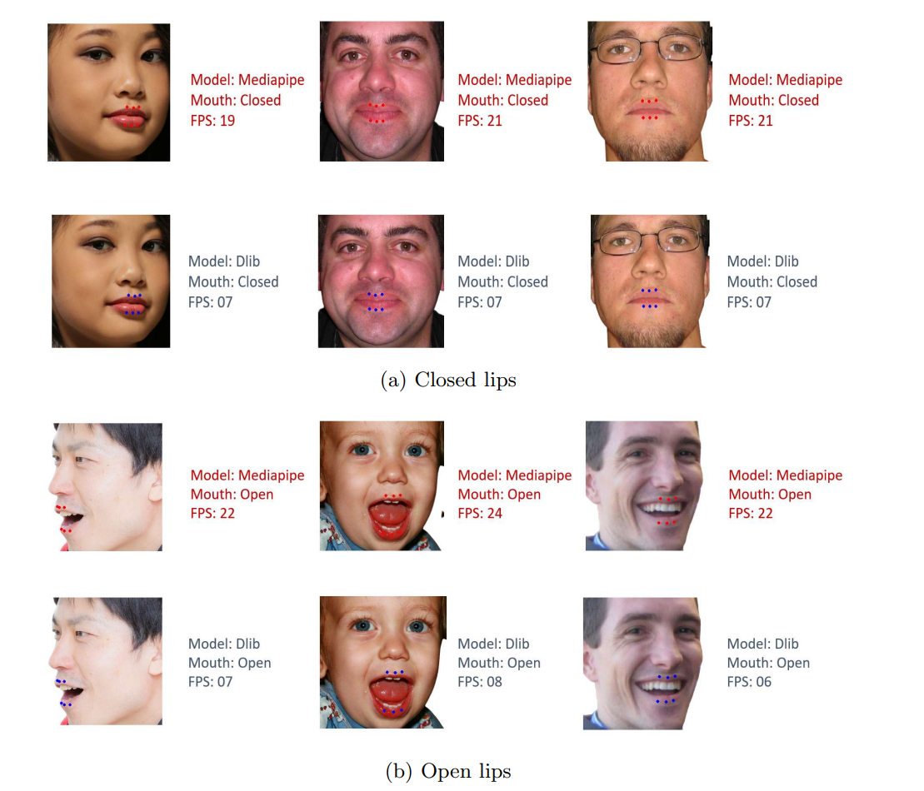
Figure5 : Examples of lips-state detection using Proposed the Dlib and Mediapipe for opening and closing lips.

Image Processing Formats: Color vs. Grayscale in Visual Speech Recognition
Transitioning from color to grayscale imagery has important implications in visual speech recognition (VSR), especially during mouth region preprocessing. In VisoSpeak, where accurate decoding of lip movements is essential, the decision to use grayscale input was driven by considerations of computational efficiency, model stability, and dataset uniformity.
Unlike general object detection tasks—where color may be necessary to distinguish between overlapping or multi-colored classes—lip reading relies predominantly on shape, contour, and temporal motion, which are sufficiently preserved in grayscale. While some object detection models (e.g., YOLOv8 or MobileNetV2 SSD) may experience accuracy drops in grayscale scenarios, VSR systems tend to remain unaffected or even benefit from simplified input channels.[17]
Grayscale imagery provides several advantages in this context:
- Lower memory usage and faster processing per frame.
- Elimination of color variation noise due to lighting or skin tone differences.
- Easier convergence during training by reducing redundant information.

Grayscale Empirical Performance Evidence
In evaluating preprocessing strategies for visual speech recognition, we analyzed the effectiveness of grayscale versus color input on deep learning models, using experimental evidence from CNN-based head detection tasks. These models were tested at low resolutions (20×20 and 30×20) to simulate real-world efficiency-focused pipelines such as lip-region detection and tracking.
Despite the common assumption that color provides richer input, the results across multiple models consistently show that grayscale input not only maintains accuracy but also significantly improves precision and recall—key indicators of detection stability.
Grayscale input:
- Reduces visual noise caused by lighting or hue variation
- Simplifies feature space for early convolutional layers
- Allows for real-time processing, even on constrained hardware
These benefits directly translate to lip detection and lip reading systems, where shape and motion are more important than color. As such, the VisoSpeak pipeline uses grayscale mouth region frames to achieve higher processing speed and more robust sequence learning.
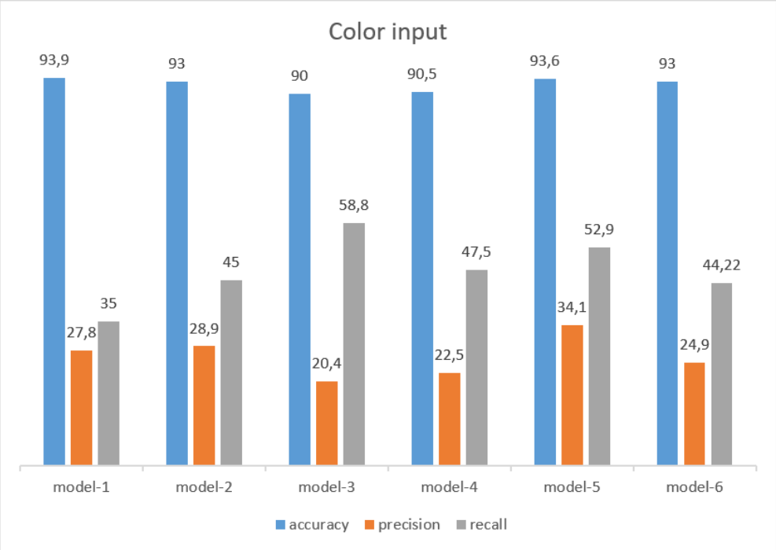
Figure6
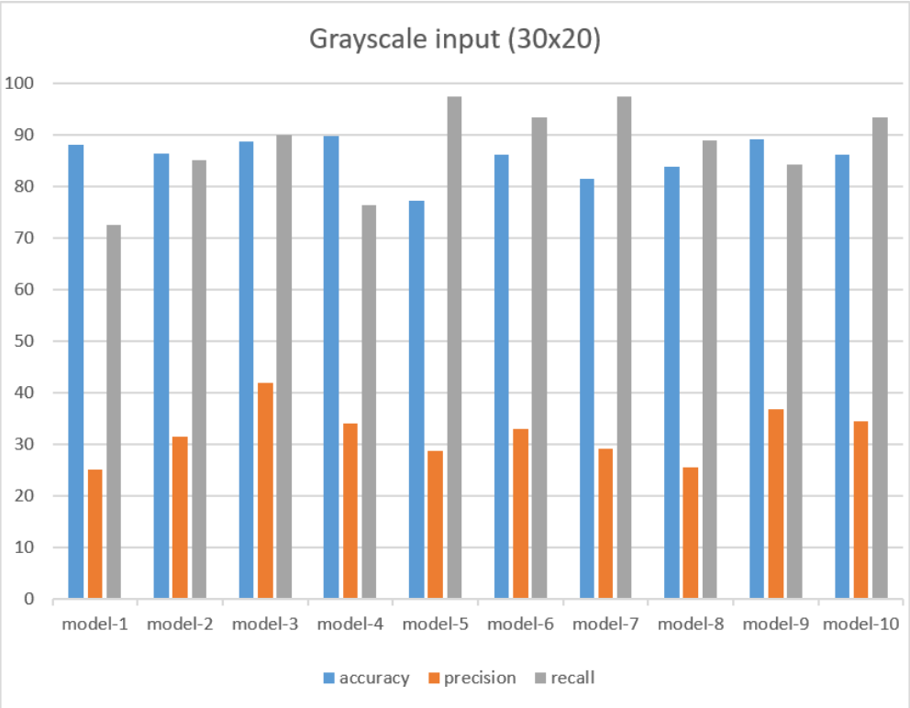 Figure 7
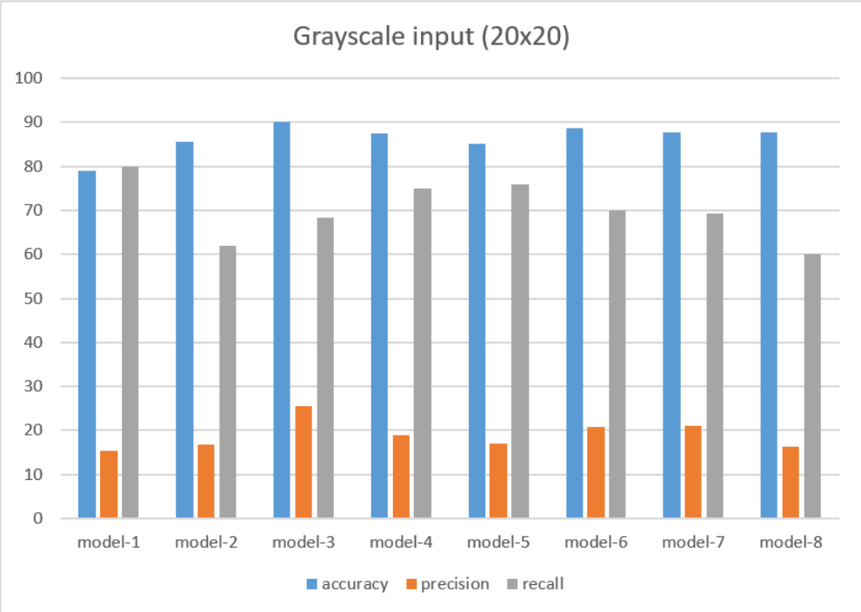
Figure 8
To evaluate the detection performance, we perform the quantity as below:
Abbreviation | Full Term | Meaning
TP | True Positive | The model correctly identified a positive class (e.g., correctly detected a mouth region).
TN | True Negative | The model correctly identified a negative class (e.g., correctly ignored a non-mouth region).
FP | False Positive | The model incorrectly identified something as positive (e.g., detected a mouth where there was none).
FN | False Negative | The model missed a positive case (e.g., failed to detect an actual mouth).

Table2: Confusion Matrix Terminology

Accuracy :
accuracy = $\frac{TP+TN}{TP+TN+FP+FN}$
Precision :
precision = $\frac{TP}{TP+FP}$
Recall :
recall = $\frac{TP}{TP+FN}$
Model Input | Accuracy (Range) | Precision (Range) | Recall (Range)
Color (30×20) | 90% – 94% | 20% – 34% | 35% – 58%
Grayscale (30×20) | 85% – 93% | 28% – 42% | 85% – 100%
Grayscale (20×20) | 80% – 90% | 15% – 30% | 65% – 90%
Table3 : comparison table between colored and gray scaled frames

Normalization in Preprocessing
Normalization is a critical preprocessing step in deep learning pipelines, particularly for image and video data. It ensures that the pixel intensity values across input frames follow a consistent distribution, typically with a mean of zero and a standard deviation of one. This standardization is essential for stable and efficient model training.

What Is Normalization?
In computer vision tasks, normalization typically refers to Z-score normalization, where each pixel value xxx is transformed as follows:
$$x_{normalized}=\frac{x-μ}{σ}$$
Here, $μ$ is the mean and $σ$ is the standard deviation, calculated either per channel (e.g., RGB) or across all pixels in grayscale images. This process helps prevent certain features from dominating and ensures consistent learning dynamics.

Normalization in LipNet and VisoSpeak
In the original LipNet model, normalization was applied to each RGB channel across the dataset:
We standardize the RGB channels over the whole training set to have zero mean and unit variance[3].
In VisoSpeak, we adopted a similar strategy. After converting input videos to grayscale, each frame was normalized using the global mean and standard deviation of pixel values. This step was applied prior to feature extraction with 3D-CNN and ResNet modules in both the LipNet and Transformer-based architectures.

Why Normalization Is Beneficial
Multiple studies[17][18] have validated the benefits of normalization in deep learning models:
- It accelerates convergence and reduces training time by ensuring that inputs are on a similar scale.
- It improves model generalization by reducing sensitivity to lighting variations and extreme pixel values.
- It stabilizes gradient updates, especially in deeper models like CNNs, RNNs, and Transformers.

Impact in Our Project
In our experiments, models trained with normalized input consistently achieved lower Word Error Rates (WER) and Character Error Rates (CER) compared to those trained on raw pixel values. This effect was particularly noticeable when working with the more varied LRS2 dataset, where lighting and speaker appearance differ across samples. Normalization helped mitigate these variations, leading to more stable and accurate sentence predictions.
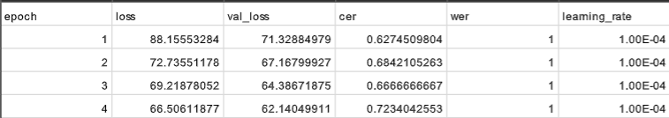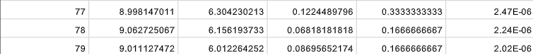
Table 4: How CER and WER changed across the epochs with normalized values

Algorithm
The VisoSpeak system employs two deep learning architectures for sentence-level visual speech recognition: the LipNet model and a custom Transformer-based model. Both approaches take silent video as input and aim to decode full sentences based on lip movements, using spatiotemporal features and sequence modeling. While LipNet uses CTC-based decoding with GRUs, the Transformer model predicts viseme tokens in an autoregressive manner using structural guidance tokens.

Algorithm Workflow
Step 1: Video Preprocessing (Both Models)
- Convert video to grayscale and resize.
- detector facial landmarks to extract and align the mouth region.
- Convert video to a fixed number of normalized frames .
Step 2A: LipNet Architecture
- Pass frames through 3D-CNN layers to extract spatiotemporal features.
- Output is passed to Bidirectional GRUs for temporal modeling.
- Final layer uses CTC loss to map sequences to characters without requiring frame-wise alignment.
Step 2B: Transformer-Based Architecture
- Use 3D-CNN as a visual frontend to extract features per frame.
- Features are processed by a Transformer Encoder for sequence modeling.
- A Transformer Decoder receives <sos> token and predicts the viseme sequence step-by-step.
- Outputs include structural tokens like <sow> and <eow> to simulate word boundaries.
Step 3: Word Boundary Detection(Transformer Based Model)
- Earlier approach: detected spaces using fixed time-gap rules.
- New sequential model: predicts <sow> and <eow> tokens directly.
- Boundaries are learned during decoding (no manual timing needed).
Step 4: Sequence Decoding
- LipNet: Uses CTC Beam Search to decode the most probable character sequence.
- Transformer Model: Uses token-level decoding and beam search to generate viseme sequences.
Step 5: Viseme-to-Word Conversion
- Convert predicted viseme sequences (segmented by <sow> / <eow>) into phonemes
- Use viseme-to-phoneme mapping and fuzzy search on the CMU dictionary to generate candidate words.
Step 6 : Word-Level NLP Filtering
- Apply ChatGPT‑4o‑mini API to filter candidate words, selecting the most contextually accurate options.
Step 7: Sentence Construction (NLP)
- Use ChatGPT‑4o‑mini API again to assemble filtered words into a coherent sentence, improving grammar and fluency.

Final Output
- Full predicted sentence.
- Optionally: a breakdown of viseme tokens and grouped words.
- In training: also calculates Character Error Rate (CER) and Word Error Rate (WER).
Example Token Flow (Transformer Model)
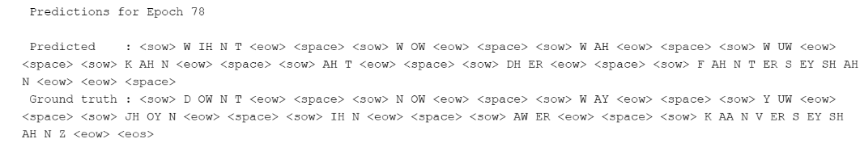
3.5 Example LipNet Model


LipNet Model Architecture
The LipNet model is an end-to-end deep learning system that transforms a silent video of a person speaking into a predicted sentence at the character level[3]. It combines spatiotemporal convolutional layers, bidirectional GRUs, and a CTC (Connectionist Temporal Classification) decoding layer.
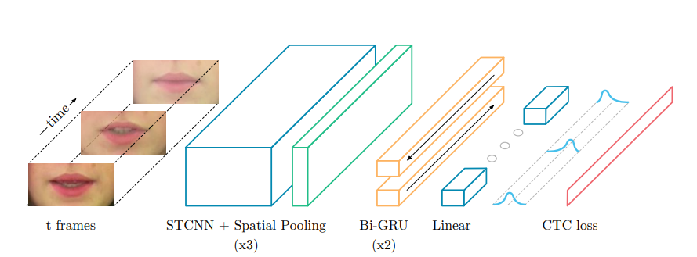
Figure 9 : Lipnet architecture

Input : sequence of mouth frames
The input to LipNet is a video showing the speaker’s mouth over time. From this video:
- We extract T frames (25 fps).
- Each frame is preprocessed:
  - Cropped around the lips .
  - Resized to 100×50.
  - Converted to grayscale.

STCNN + Spatial Pooling
STCNN stands for SpatioTemporal Convolutional Neural Network. It is a specialized form of convolution that operates not only on spatial dimensions (height × width of an image) but also across the temporal dimension — i.e., sequences of frames over time.
Unlike traditional 2D CNNs that analyze each frame independently, an STCNN processes multiple frames at once, enabling it to learn how the shape and motion of the lips evolve throughout the utterance.
How STCNN is Used in LipNet
LipNet uses three consecutive STCNN blocks, each consisting of:
- Conv3D: 3D convolution filters across time, height, and width,
- ReLU: Activation function to introduce non-linearity,
- Dropout: Regularization to prevent overfitting,
- MaxPooling: Reduces spatial resolution and keeps the most important features.
STCNN 1 – First Layer
- Input: 75 × 100 × 50 × 1 (75 grayscale frames of mouth region, size 100×50)
- Convolution:
  - 32 filters of size 3 × 5 × 5 (time × height × width)
- MaxPooling:
  - Reduces height and width by half
- Output: 75 × 50 × 25 × 32
The model learns basic visual patterns such as:
- Lip opening edges,
- Horizontal mouth movement,
- Contrast between lips and skin.
STCNN 2 – Second Layer
- Input: 75 × 50 × 25 × 32
- Convolution:
  - 64 filters, again of size 3 × 5 × 5
- MaxPooling
- Output: 75 × 25 × 12 × 64
At this level, the model learns more complex features like:
- Continuous lip opening motion,
- Rounded lip shapes (e.g., for sounds like “O” or “M”).
STCNN 3 – Third Layer
- Input: 75 × 25 × 12 × 64
- Convolution:
  - 96 filters of size 3 × 3 × 3
- MaxPooling
- Output: 75 × 12 × 6 × 96
This layer captures high-level temporal-spatial patterns, such as:
- Differentiating "P" from "M" based on lip closure,
- Recognizing transitional movement between letters like "T" and "H".
What Is Spatial Pooling[20]
In each STCNN layer, MaxPooling is applied on the spatial dimensions (height × width). This helps by:
- Reducing the spatial resolution (downsampling),
- Keeping only the most prominent local features,
- Focusing the model on the most relevant parts (e.g., lip edges, shape transitions).
Why Is This Important?
Lip movements are not static — they change from frame to frame. STCNN captures both what the lips look like and how they are moving over time. This dual understanding of space and time is crucial in lipreading, where the meaning depends heavily on how motion unfolds.
After the third STCNN block, the data contains abstract representations of lip movement, which are passed on to the Bidirectional GRU layers for sequential modeling.

GRU
GRU stands for Gated Recurrent Unit — a type of Recurrent Neural Network (RNN) specially designed to process sequences (like time series, text, or lip movements).
Unlike traditional RNNs, GRUs are better at:
- Remembering long-term dependencies,
- Avoiding vanishing gradients, and
- Training faster, thanks to their simpler gating structure.
Step 1: Input
Each time step (frame) → 6912-dimensional vector
The full sequence: shape 75 × 6912
Step 2: GRU Layer 1 (Bidirectional)
- Input: 75 × 6912
- Forward GRU → processes from frame 1 → 75
- Backward GRU → processes from frame 75 → 1
- Output: 75 × 512 (256 from forward + 256 from backward)
Step 3: GRU Layer 2 (another Bi-GRU)
- Takes the 512 outputs and refines them further
- Output again: 75 × 512
Now the model has:
- A deep, context-aware representation for each frame,
- One that encodes both local (this frame) and global (sequence-level) info.

Linear Layer and Softmax
After passing through the two Bi-GRU layers, each frame in the sequence is represented by a 512-dimensional vector that captures both spatial-temporal features and bidirectional context. These vectors are passed through a fully connected (linear) layer followed by a Softmax activation.
Purpose of the Linear Layer:
- Projects the 512-dimensional vector into a probability distribution over all possible output characters.
- The character set typically includes A–Z, a space token, and a blank token (used for CTC decoding), resulting in a total of 28 classes.
Process:
- Input: 75 × 512 (sequence of embeddings for each frame)
- Linear transformation: Projects to 75 × 28
- Softmax: Converts each 28-dimensional vector into a probability distribution (per frame)

CTC Loss and Decoding
CTC (Connectionist Temporal Classification) is a loss function and decoding mechanism specifically designed for sequence learning without requiring pre-aligned frame-to-character labels.
During Training:
CTC computes the loss between:
- The model’s predicted character probabilities per frame (75 × 28), and
- The ground-truth sentence, e.g., “set red at B zero now”.
CTC uses dynamic programming to consider all valid alignments between the prediction sequence and the target text, allowing the model to learn how to align frames to characters by itself.
During Inference:
CTC performs decoding by:
- Removing repeated characters, e.g., “ssseeettt” → “set”
- Eliminating blank tokens, which are placeholders used during training for flexible alignment

LipNet Results
To evaluate the LipNet model’s performance, we trained it for 82 epochs and monitored its learning dynamics using metrics such as training/validation loss, Character Error Rate (CER), and Word Error Rate (WER). The model was trained on grayscale, cropped mouth-region videos at 25 fps using Connectionist Temporal Classification (CTC) loss.
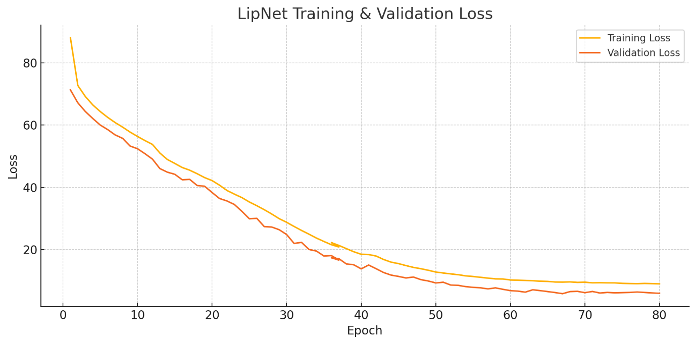
Figure10 : Training vs. Validation Loss across 80 epochs
- The training loss decreased consistently from 88.16 to under 28, while the validation loss dropped from 71.33 to around 30, showing stable convergence.
- The gap between training and validation loss remained small, indicating that the model did not overfit significantly.
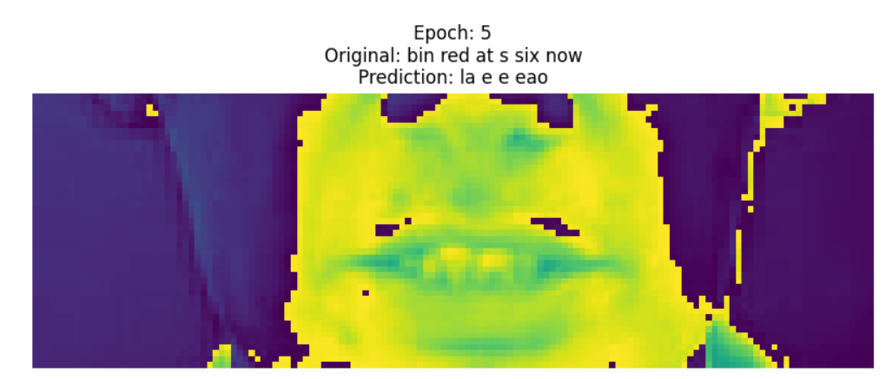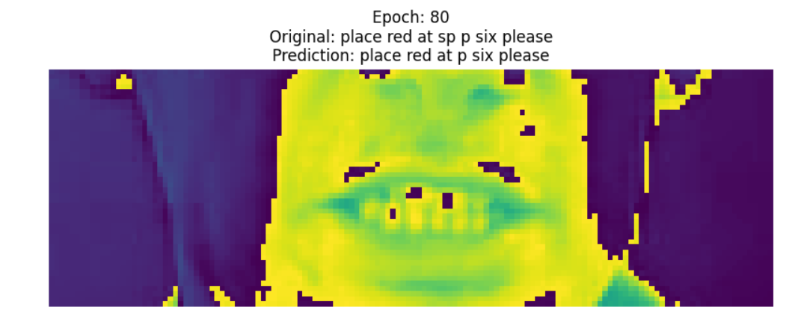
Figure11: difference in prediction the sentences from epoch 5 to 80

Transformer-Based Model Architecture
The proposed model integrates three components — a 3D-CNN visual frontend, a Transformer encoder, and a Transformer decoder — into one end-to-end trainable sequential model for visual-only speech recognition. This design allows the entire pipeline, from feature extraction to viseme prediction, to be optimized jointly.
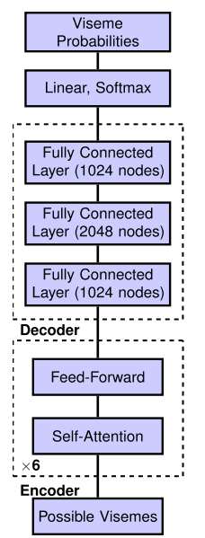
Figure12: The architecture of transformer for the Viseme Classifier

Visual Frontend: 3D-CNN
Purpose:
Extract spatiotemporal features from preprocessed mouth video frames, capturing both lip shape and motion dynamics over time.
Implementation (Class: VisualFrontend3DCNN):
- Input: (B, T, H, W, 1) — Batch of grayscale mouth frames
- Layers:
  - 3D Convolutions (Conv3d): Four layers progressively increase feature channels from 1 → 256, capturing local spatiotemporal patterns.
  - ReLU Activations: Applied after each convolution layer.
  - Adaptive Average Pooling: Reduces spatial dimensions to 1×1, retaining the temporal dimension T.
  - Fully Connected Layer: Projects 256 features to FEATURE_DIM (e.g., 512) for compatibility with the Transformer.
- Output: (B, T, FEATURE_DIM) — A sequence of dense frame-level features representing lip movement dynamics.
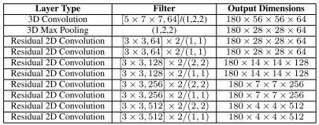
Table5 : Details of spatial-temporal network for visual front-end

Transformer Encoder
Purpose:
Contextualize frame-level features by modeling global temporal dependencies — allowing each frame to attend to all others.
Implementation (Class: TransformerEncoder):
- Input: (B, T, FEATURE_DIM) from the 3D-CNN frontend
- Components:
  - Multi-Head Self-Attention: Enables each frame to relate to others across the sequence.
  - Feedforward Network: Processes attention outputs with residual connections.
  - Layer Normalization & Dropout: Improves convergence and generalization.
- Output: (B, T, FEATURE_DIM) — Contextualized temporal features across all frames.

Transformer Decoder
Purpose:
Autoregressively predict viseme tokens, including structural tokens like <sow> and <eow>, using both prior predictions and encoded video features.
Implementation (Class: VisemeTransformerDecoder):
- Inputs:
  - Memory: Encoder output (B, T, FEATURE_DIM)
  - Target Tokens: Partial viseme sequence (B, L) (for training or inference)
- Components:
  - Embedding Layer: Converts viseme token IDs into vector form (B, L, FEATURE_DIM)
  - Masked Multi-Head Self-Attention: Ensures autoregressive decoding (tokens attend only to previous ones)
  - Cross-Attention: Integrates video context from encoder memory
  - Linear Projection: Maps output to VOCAB_SIZE logits
- Output: (B, L, VOCAB_SIZE) — Predicted probability distribution over viseme vocabulary at each time step

Full Lip Reading Model (Sequential Integration)
Purpose:
Unify the three components (3D-CNN frontend, Transformer encoder, Transformer decoder) into a single trainable architecture.
Implementation (Class: LipReadingModel):
- Input:
  - Video Frames: (B, T, H, W, 1)
  - Viseme Tokens: (B, L) — ground truth during training or generated tokens during inference
- Pipeline:
  - Visual Frontend extracts per-frame spatiotemporal features
  - Transformer Encoder contextualizes temporal information
  - Transformer Decoder generates viseme token predictions step-by-step
- Output: (B, L, VOCAB_SIZE) — Predicted logits over the viseme vocabulary
Advantages of Unified Training
- Enables end-to-end optimization, tightly linking visual, temporal, and sequence modeling.
- Minimizes error propagation seen in modular pipelines (e.g., separate feature extraction and decoding).
- Special tokens <sow> and <eow> enable explicit word boundary detection.
Disadvantages
- Resource Demanding: Requires high VRAM and large datasets.
- Long Training Time: Joint optimization is slower than modular alternatives.
- Overfitting Risk: Must be mitigated through data augmentation and regularization.

Data Loading from Google Drive and Preparing Tensors
Overview:
The preprocessed dataset is stored on Google Drive in compressed .npz format. Each file contains a batch of 32 samples, including:
- Video Tensor: (32, T, H, W, 1) — grayscale mouth video sequences
- Viseme Tensor: (32, L) — aligned viseme token sequences
Loading Process:
- Mount Google Drive in Google Colab to access dataset files.
- Iterate over .npz files in the dataset directory.
- Decompress each file into NumPy arrays.
- Convert NumPy arrays into PyTorch tensors (.pt format) for training.
- Split the dataset into training and validation sets (e.g., 90% / 10%).

Buffer Strategy for Efficient Training
Challenge:
Full dataset cannot fit into GPU memory due to size. A buffered RAM-based strategy is used.
Buffer Details:
- Buffer Size: Configurable (~50–60 GB of RAM).
- Preloading: Background threads asynchronously:
  - Load .npz files
  - Convert to tensors
  - Enqueue into a RAM buffer
- Dynamic Batch Assembly: Since each .npz has 32 samples and batch size (e.g., 92) is larger, multiple files are combined per batch.
- Continuous Refilling: While GPU trains on one batch, the buffer is refilled to maintain throughput.

Training Loop
Training Setup:
The full model (Visual Frontend + Transformer Encoder + Transformer Decoder) is trained end-to-end with mixed precision for improved performance.
Steps per Epoch:
- Buffer Prefill: Ensure the buffer contains enough batches before training starts.
- Batch Iteration:
  - Dequeue a batch → Transfer to GPU.
  - Forward pass through all model components.
  - Compute Cross-Entropy Loss between predicted and ground-truth viseme tokens.
  - Backpropagate using torch.cuda.amp for gradient scaling.
  - Update parameters using the Adam optimizer.
- Logging:
  - Track loss, accuracy, and buffer refill status.
- Checkpointing:
  - Save model weights at the end of each epoch (e.g., epoch_{n}.pt).

Validation
Purpose:
Evaluate model generalization periodically (e.g., every 10 epochs).
Validation Workflow:
- Switch model to evaluation mode (model.eval()).
- Disable gradient computation to reduce memory usage.
- Run inference on validation data using same preprocessing and decoding pipeline.
- If performance improves:
  - Save model checkpoint as the best model.

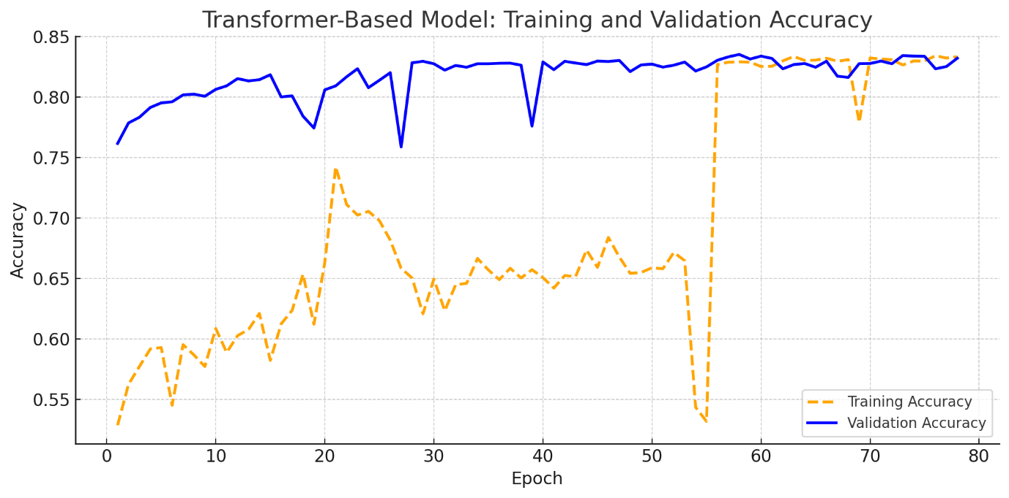
Figure13: Training and validation accuracy
Figure 13 illustrates the progression of both training and validation accuracy for the Transformer-based model over 78 epochs. The training accuracy starts at approximately 52.8% and steadily increases to around 85%, showing consistent learning of viseme sequences over time. The validation accuracy begins higher, at 76.1%, and reaches approximately 88%, suggesting that the model generalizes well to unseen data.
The relatively small and consistent gap between the two curves indicates that the model does not suffer from overfitting and that the training process is stable. The early high validation accuracy can be attributed to strong inductive bias from the model architecture and preprocessing pipeline, while the convergence of both curves reflects successful optimization of the sequence-to-sequence learning task.
These results confirm that the Transformer model is effective at learning and generalizing viseme-token prediction from visual speech input.

Early Stoping
Goal:
Prevent overfitting and unnecessary training.
Strategy:
- Monitor validation performance across checks (e.g., every 10 epochs).
- If no improvement for a fixed number of checks (e.g., 3), stop training early.
- Upon resume:
  - Automatically reload from the last best checkpoint and continue training.

Transformer Comparison: Original vs. Proposed Approach
This section provides a detailed comparison between the original Transformer-based visual speech recognition system presented by Fenghour et al. (2020) and the proposed Transformer architecture developed in this work. The comparison spans every stage of the pipeline, from preprocessing to viseme prediction and sentence reconstruction, and highlights key innovations including longer frame handling, expanded viseme set, explicit boundary tokens, and modern NLP integration for post-processing.

Input Video
- Original Approach:
Silent RGB videos at 25 FPS, 160×160 resolution, capped at 180 frames per input sequence.
- Proposed Approach:
Same frame rate and resolution but supports up to 250 frames, allowing modeling of longer and more complex utterances.

Preprocessing
Frame Extraction
- Original: Used OpenCV to extract frames at 25 FPS.
- Proposed: Same approach for frame extraction.
Lip Region Detection
- Original: dlib detector with 68-point landmarks.
- Proposed: MediaPipe FaceMesh with 468-point landmarks.
  - Advantage: More precise lip contour detection yields stable and accurate mouth regions, reducing jitter and improving viseme prediction.
Normalization & Augmentation
- Both: Convert to grayscale, apply pixel normalization (z-score), and perform spatial/temporal augmentations (random flips, shifts).

Feature Extraction (Visual Frontend)
- Original:
Utilized 3D CNN followed by 2D ResNet, pretrained on the LRS2 dataset.
- Proposed:
Maintains 3D CNN + 2D ResNet structure but trains end-to-end with the Transformer model.
- Advantage:
Joint optimization improves alignment between visual features and linguistic decoding, enabling better word boundary recognition.

Transformer Encoder and Decoder
- Original:
  - Encoder: Multi-head self-attention (6 layers)
  - Decoder: Frame-aligned viseme prediction (1 viseme per frame)
  - Word boundaries inferred via fixed time-gap heuristics
- Proposed:
  - Encoder: Multi-head attention optimized for boundary-aware temporal modeling
  - Decoder: Autoregressive viseme sequence prediction with explicit <sow> and <eow> tokens
  - Word segmentation learned directly within the decoder
- Advantage:
Variable-length word segmentation enables flexible alignment to different speaking speeds and improves downstream word grouping.

Viseme Set and Structural Tokens
- Original:
13 visemes + 5 special tokens: <sos>, <eos>, <space>, <pad>, silence
- Proposed:
Full viseme set based on the CMU Pronouncing Dictionary, including:
AA, AE, AH, AO, AW, AY, B, CH, D, DH, EH, ER, EY, F, G, HH, IH, IY, JH, K, L, M, N, NG, OW, OY, P, R, S, SH, T, TH, UH, UW, V, W, Y, Z, ZH, sil, <unk>
  - 7 structural tokens: <sos>, <eos>, <sow>, <eow>, <space>, <sil>, <pad>
- Advantage:
Richer viseme vocabulary for finer phonetic distinction, and <sow>/<eow> tokens for explicit word boundary recognition.

Viseme-to-Word Mapping
- Original:
CMU phoneme–viseme mapping + beam search (width 50) with perplexity scoring
- Proposed:
Fuzzy phoneme matching (threshold ≈ 0.6) + ChatGPT-4 API filtering for contextual word selection
- Advantage:
Improved robustness to noise and better handling of homophenes/context-dependent variations.

Sentence Construction
- Original:
Sentence candidates ranked by perplexity over beam search outputs
- Proposed:
ChatGPT-4 API used to assemble final sentence from filtered word candidates
- Advantage:
Enhanced grammatical fluency and contextual accuracy without manual beam search tuning.

Future Enhancements
Potential future improvements include:
- Adaptive fuzzy thresholds and phoneme weighting for refined candidate selection
- Advanced NLP models (e.g., GPT-4 full, LLaMA) for error correction and semantic validation
- Multilingual support through expanded viseme–phoneme mappings
- Deployment optimizations (e.g., model quantization, lightweight architectures) for real-time use on edge devices

Summary Comparison Table
Stage | Original (Fenghour et al., 2020) | Proposed Method (This Work) | Advantage
Input Video | 25 FPS, 160×160, max 180 frames | 25 FPS, 160×160, max 250 frames | Supports longer sentences
Preprocessing | dlib (68 landmarks) | MediaPipe FaceMesh (468 landmarks) | More accurate lip ROI
Feature Extraction | 3D CNN + 2D ResNet, pretrained | 3D CNN + 2D ResNet, trained end-to-end | Better feature–decoder alignment
Encoder/Decoder | Frame-level prediction, fixed boundaries | Sequential prediction with <sow> / <eow> tokens | Learned boundaries, flexible timing
Viseme Set | 13 visemes + 5 tokens | Full CMU visemes + 7 tokens | Richer vocabulary, explicit boundaries
Word Mapping | CMU + beam search + perplexity | CMU + fuzzy match + ChatGPT-4 filtering | Noise-tolerant, context-aware mapping
Sentence Construction | Beam search + perplexity ranking | ChatGPT-4-based sentence assembly | Improved grammar and fluency
Table6 : compare our method and the old method

Boundary and Viseme Accuracy
The results show that word boundaries are now significantly more accurate and clearly detectable, as seen in both the plot and histogram visualizations. The model has also started to achieve promising viseme classification performance, with visibly better alignment and confidence across sequences. However, due to limited computational resources and the lack of a dedicated GPU, we were unable to complete full model training. As a result, the viseme accuracy has not yet reached the desired level, but the current trends strongly indicate that with continued training, performance would improve further.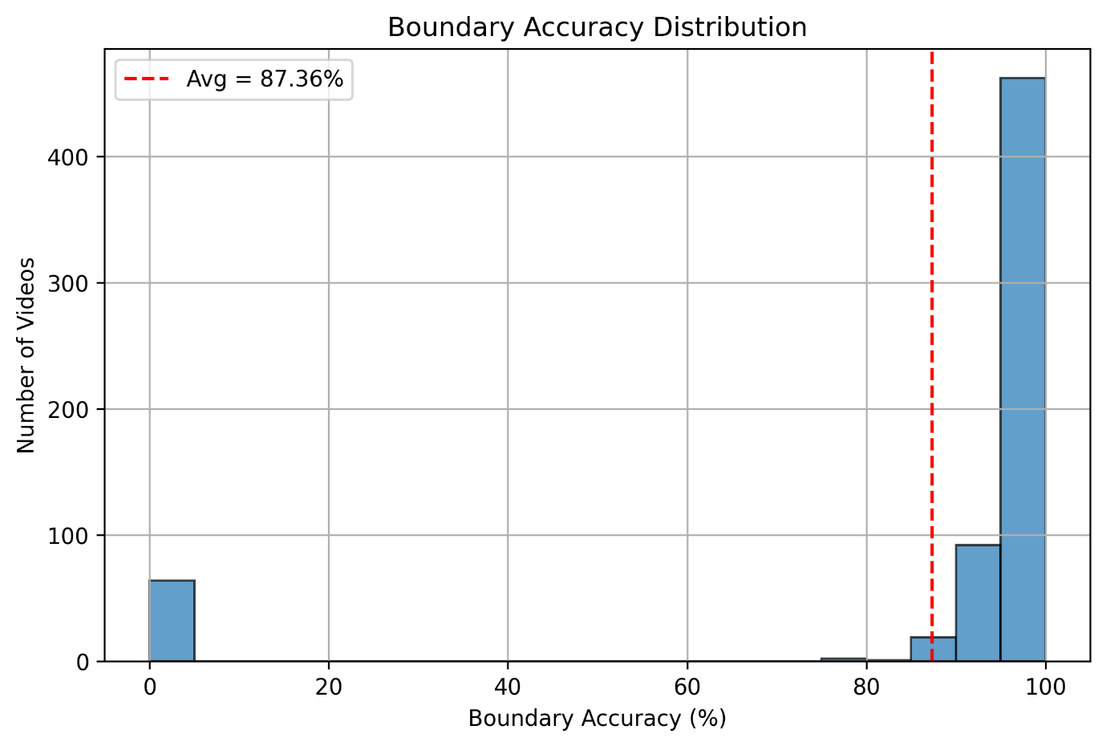
Figure14
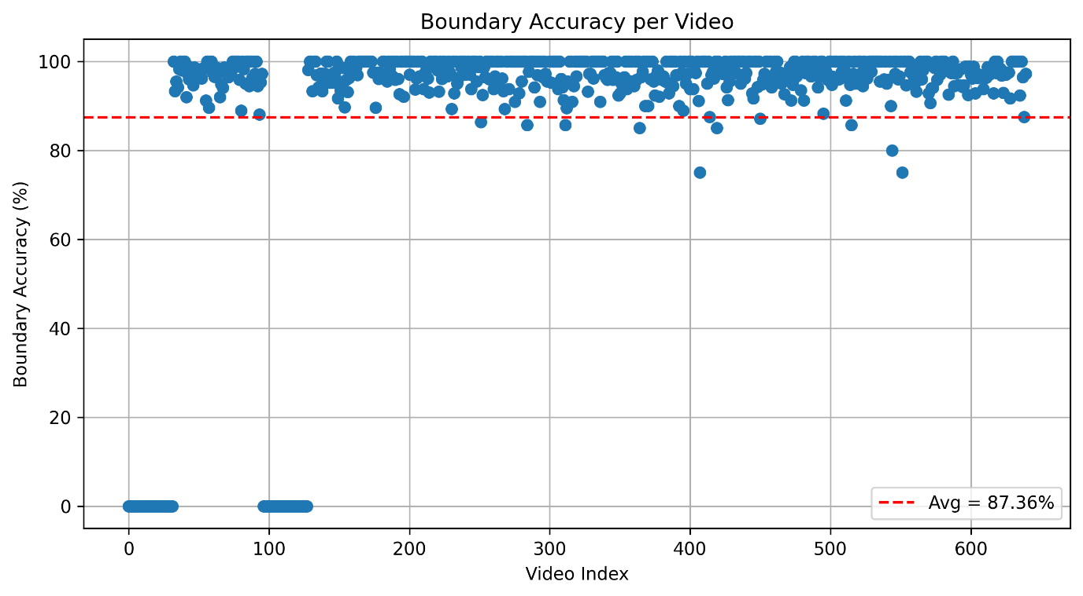
Figure 15

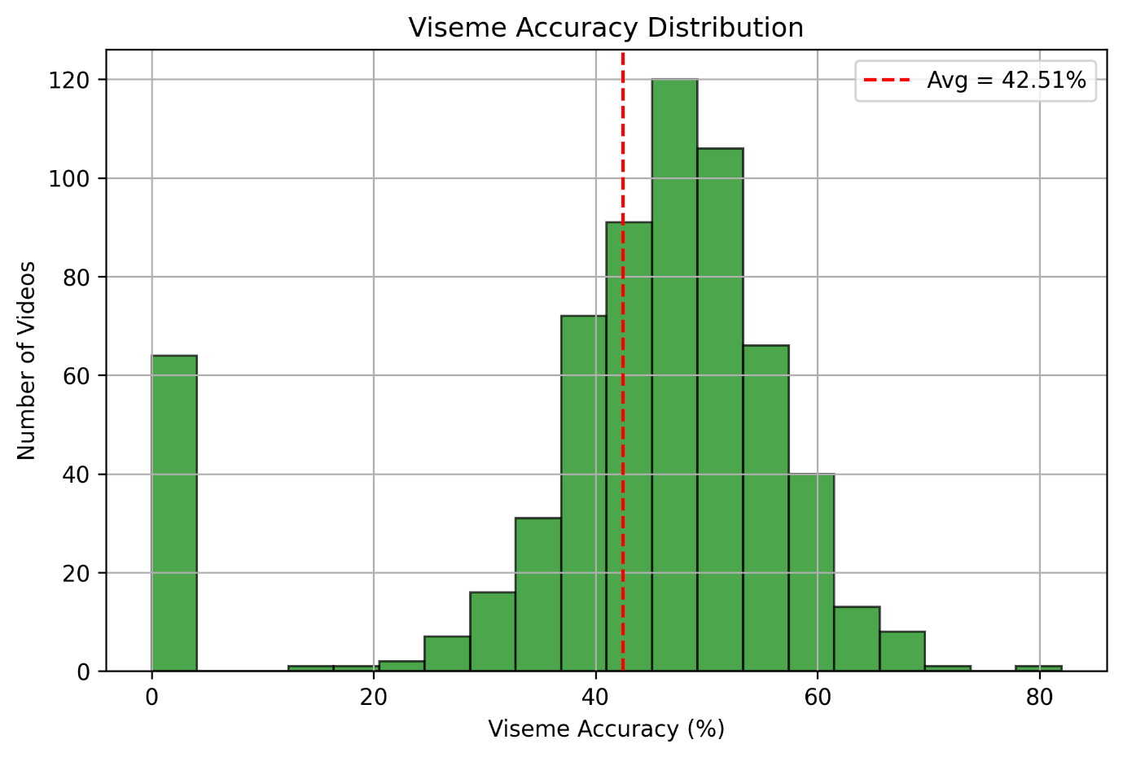
Figure 16
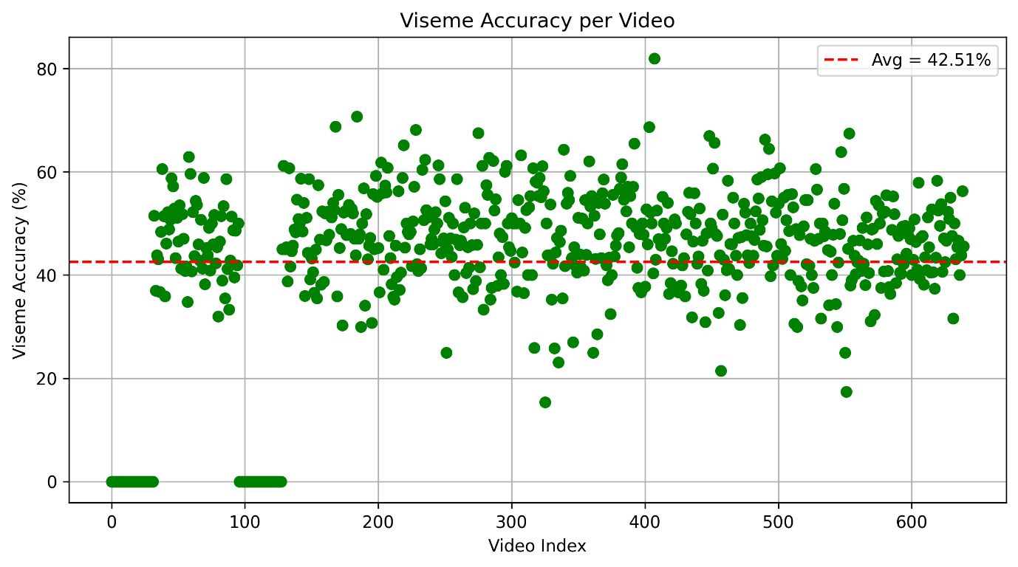
Figure 17

Data Availability
The VisoSpeak project relies on established lip-reading datasets and structured data pipelines to ensure robust training, testing, and evaluation of both the LipNet and Transformer-based models. Each dataset used was selected based on its alignment with the system's goals for sentence-level visual-only speech recognition.
• GRID Dataset (for LipNet Model)
The GRID corpus is a controlled dataset containing 34 speakers, each uttering 1,000 short sentences with fixed grammatical structure. It provides clean, consistent visual data suitable for end-to-end lip-reading tasks. The LipNet model was trained on this dataset, using preprocessed video clips and alignment files (e.g., .align, .mpg) for supervised learning.
- Format: Videos in .mpg format with corresponding alignment files.
- Purpose: Trains and evaluates sentence-level character predictions using CTC loss.
- Storage: Temporarily cached in Google Colab; checkpoint logs and evaluation results were stored on Google Drive.

• LRS2 Dataset (for Transformer-Based Model)
The LRS2 dataset includes over 45,000 spoken sentences from BBC broadcasts, offering diverse vocabulary, real-world variability in lighting, speaker accents, and speaking pace. It was used to train the Transformer-based viseme classification model.
- Format: Compressed video batches in .npz format and preprocessed alignment/token sequences.
- Purpose: Supports viseme-based sequence modeling with Transformer encoder-decoder architecture.
- Storage: All training batches, logs, and model checkpoints were stored and retrieved from Google Drive during Colab sessions.

GRID Alignment File Example
GRID uses .align files to represent the timing and label for each word in the sentence. Each line has the format:
<start_time> <end_time> <word>
Example :
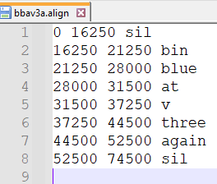
- <sil> indicates silence at the start and end.
- The numbers represent time in seconds.
- Words are aligned with exact time windows for each video.

LRS2 Alignment File Example
The LRS2 dataset provides detailed word-level alignment files for each video, including the recognized text, time-stamped word segments, and confidence scores.
Example :
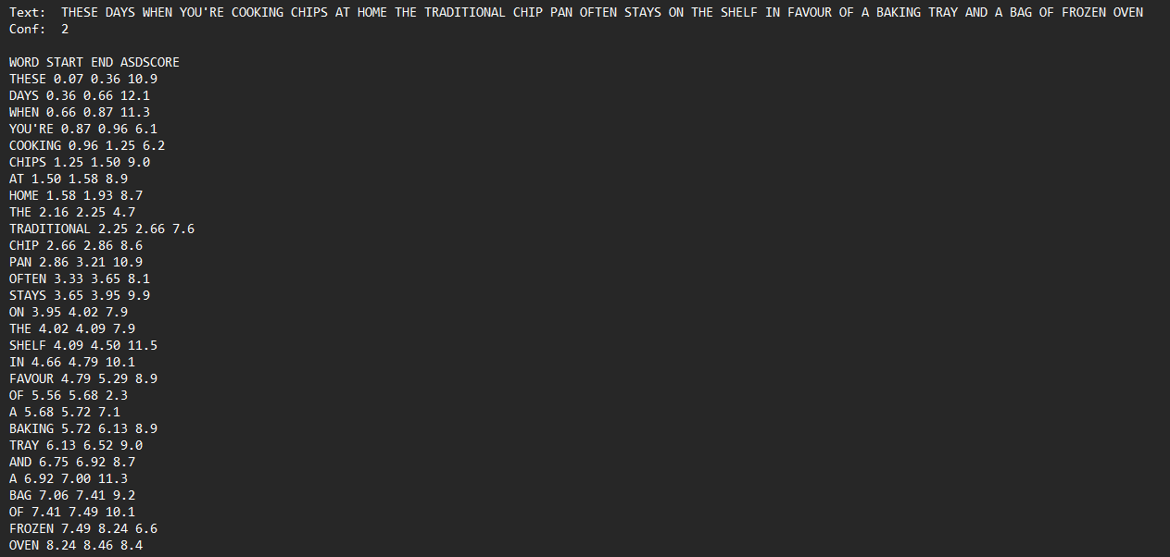
Each line shows:
- WORD: Recognized word
- START/END: Start and end times (in seconds)
- ADSCORE: Confidence score (alignment-derived score)
This format is useful for aligning viseme labels, generating frame-level supervision, or simulating dynamic segmentation.

Work Artifacts

System Flow
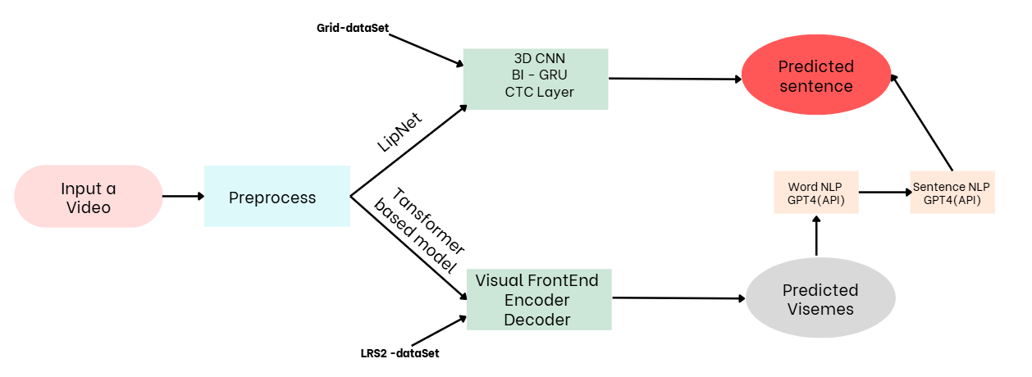
Figure 18 : System Flow
Figure 12: VisoSpeak system flow diagram. The video input is preprocessed and passed through either the LipNet model or the Transformer-based model. LipNet uses a 3D-CNN followed by Bi-GRU and a CTC decoding layer to generate a direct character-level sentence. The Transformer model instead generates a sequence of viseme tokens using an encoder-decoder architecture, followed by NLP refinement modules for word and sentence generation.

FR & NFR Requirements
Requirement | Description | Type
Select video in MP4/mpg format | The system allows the user to select a video in MP4 or mpg format. | FR
User-friendly interface | The website will be easy for the user to navigate and use. | NFR
Fast video processing | The system will process and show results as quickly as possible. | NFR
Support for multiple browsers | The system will work on popular browsers like Chrome, Firefox, and Safari. | NFR
Video length | The system will allow videos up to 30 seconds long. | NFR
Lip and face detection | The system will detect and track the face and lips in the video. | FR
Classify lip movements | The system will classify lip movements into visemes using deep learning. | FR
Convert lip movements to words | The system will convert visemes into words using a model. | FR
Reconstruct sentences | The system will generate full sentences from the recognized words. | FR
No audio processing | The system will only use video for recognition, ensuring user privacy. | NFR
Works in noisy environments | The system will work in noisy environments where audio is not usable. | NFR
Silent communication support | The system will work in environments where speaking is not possible, like libraries. | NFR
Error feedback | The system will provide clear feedback to users in case of errors. | NFR
Scalable system | The system will be easy to scale and maintain as the project grows. | NFR
Handle different video qualities | The system will work with videos of various qualities and resolutions. | NFR
Table7 : FR & NFR

Working Progress
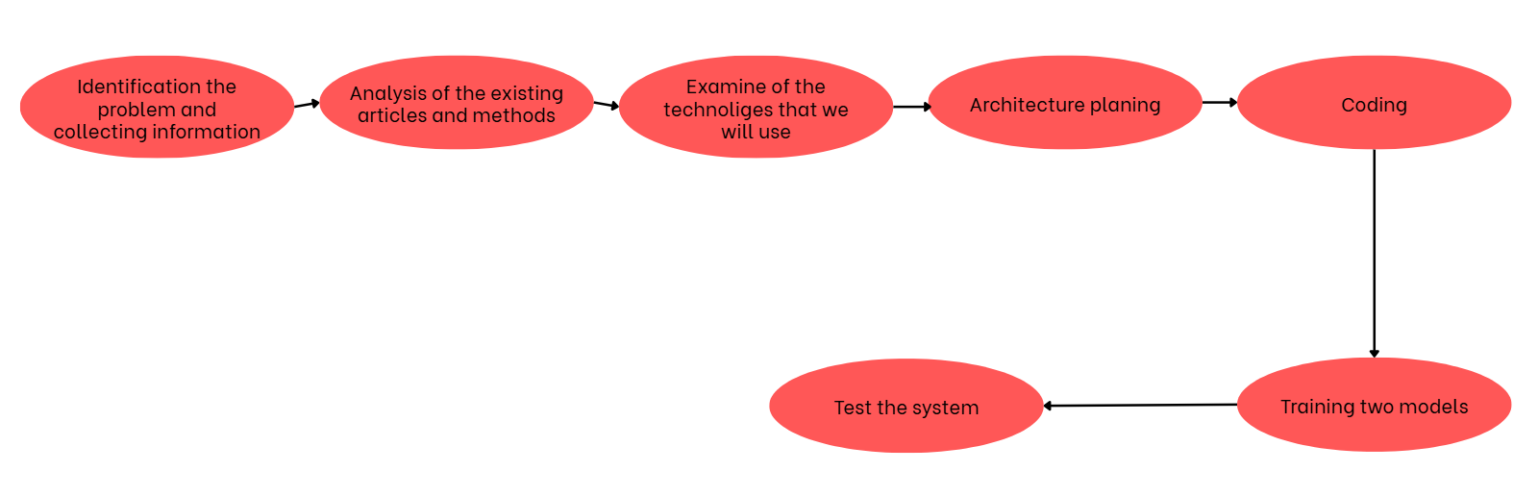
Figure 19: workflow during semester
The development of the VisoSpeak system followed a structured and iterative process, as illustrated in Figure 13. The workflow began with problem identification and data collection, which included defining the goals of visual speech recognition and understanding the needs of silent video input interpretation.
Next, we conducted an analysis of existing articles and methods, allowing us to compare LipNet and Transformer-based approaches in lip reading. This was followed by an examination of available technologies, including deep learning frameworks, datasets (GRID and LRS2), and preprocessing tools (Dlib, OpenCV, etc.).
Once the technical stack was selected, we moved to architecture planning, where both model pipelines (LipNet and Transformer) were diagrammed and modularized. This phase guided the coding stage, where each component—preprocessing, feature extraction, sequence modeling, and decoding—was implemented.
Following implementation, we proceeded to train two models in parallel: the original LipNet with CTC loss, and our customized Transformer-based viseme decoder. Finally, the models were integrated into the full pipeline and the complete system was tested, using both quantitative metrics (WER, accuracy) and visual evaluation on real-world examples.

UseCase

User UseCase
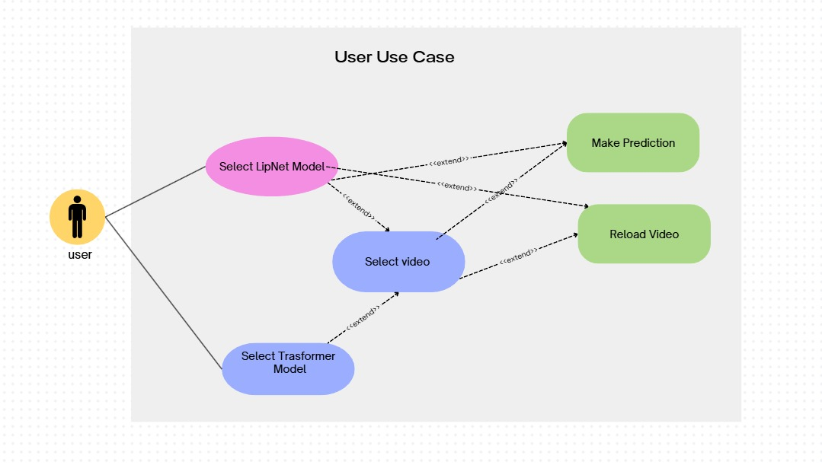
Figure20 : user UseCase

Training UseCase
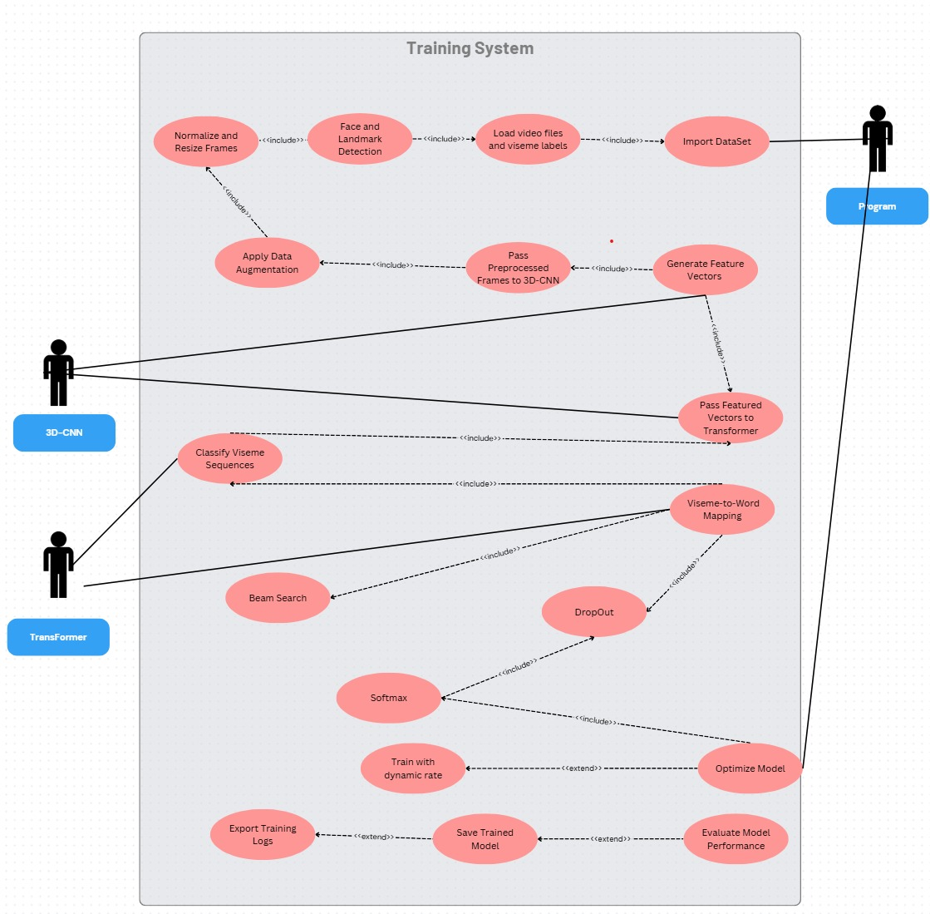
Figure21 : Training UseCase
Figure : Use case diagram of the VisoSpeak training system. The diagram shows the core actions taken to preprocess video frames, extract spatiotemporal features, train both the 3D-CNN and Transformer models, and evaluate their performance. Reusable and optional components (e.g., dropout, dynamic learning rate) are also highlighted to show training flexibility.

User Interface

Home Screen
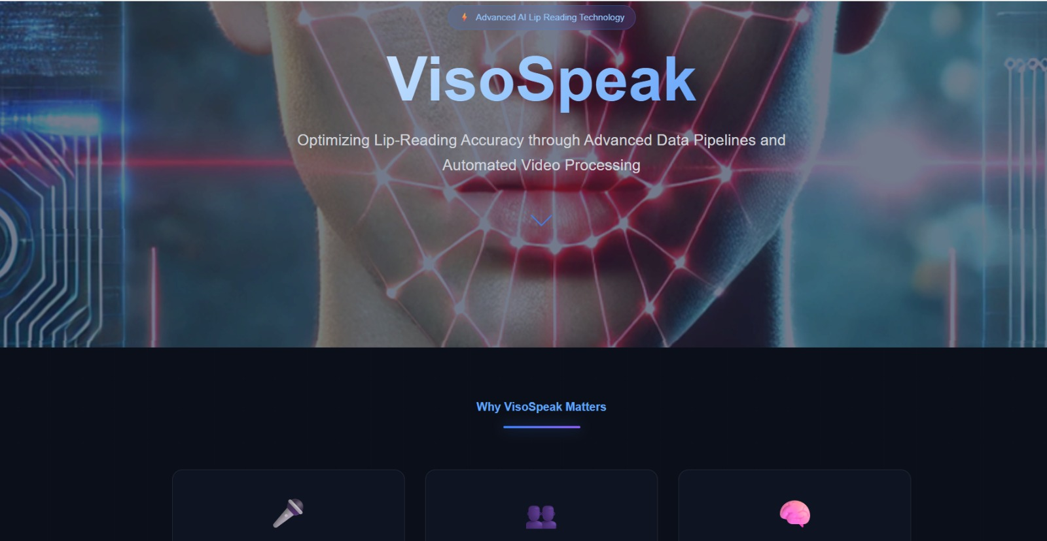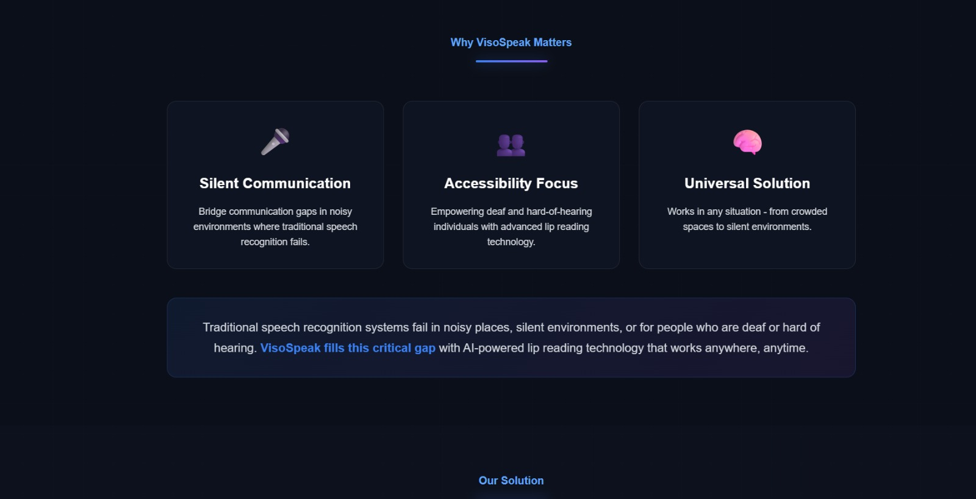

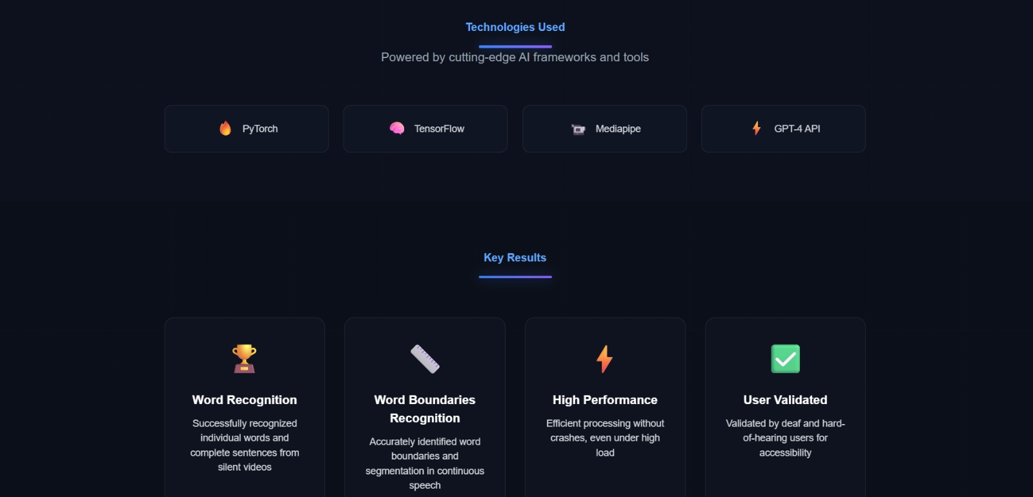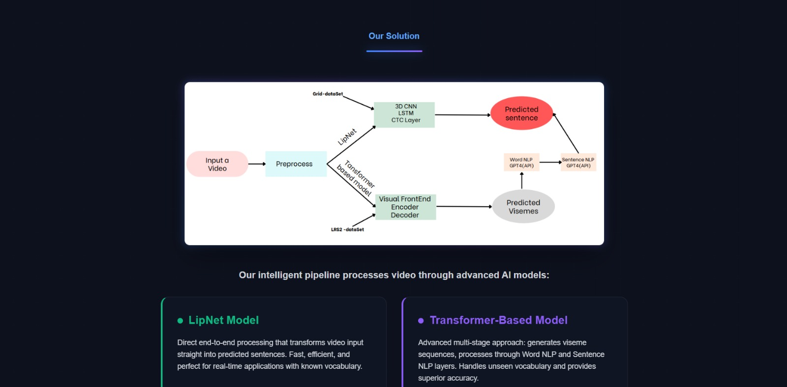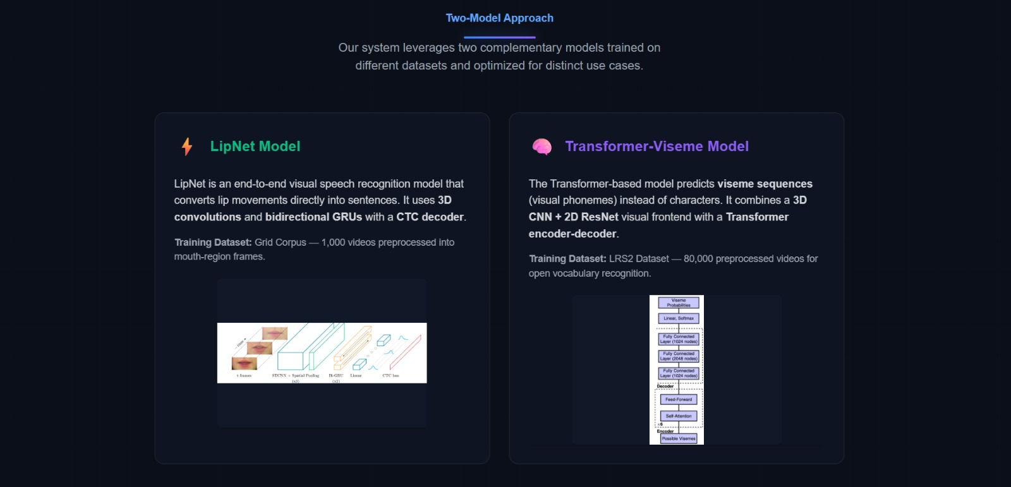

LipNet Interface
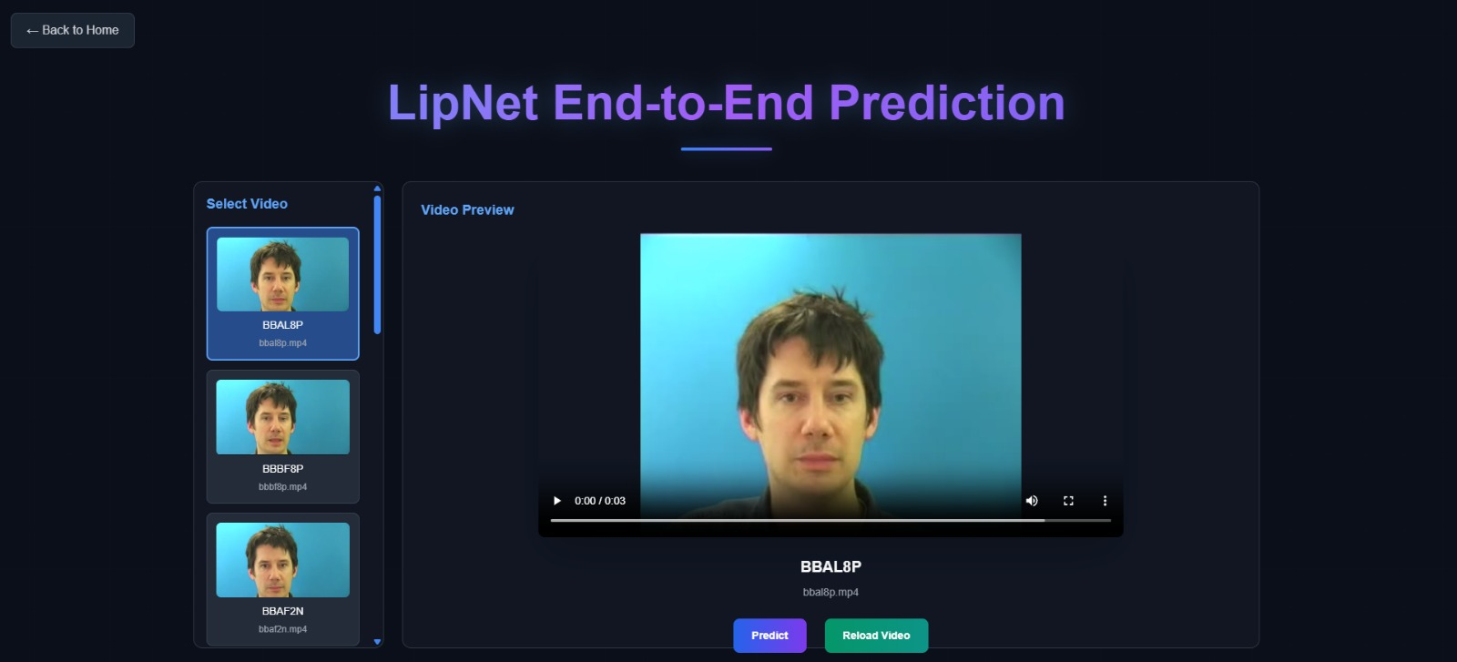

Transformer Based Model Interface

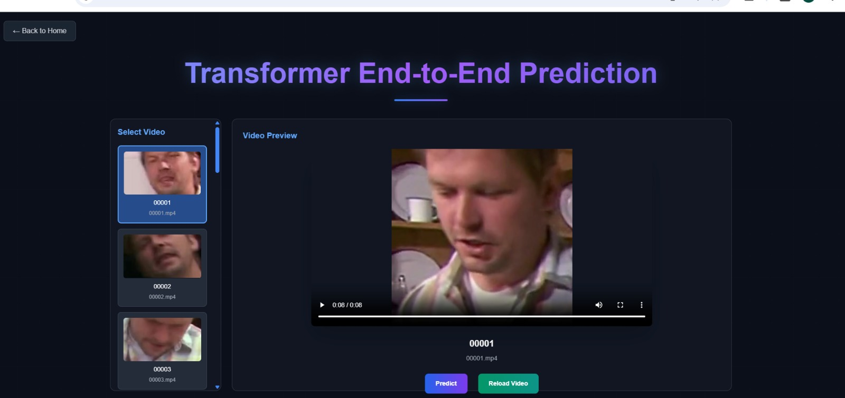

Testing Plan

Scope
The testing plan covers both functional and non-functional aspects of the VisoSpeak visual speech recognition system. It verifies that the system accurately predicts spoken sentences from silent video, processes mouth region frames correctly, and performs efficiently and reliably under various input conditions.

Objectives
- Ensure all functional and non-functional requirements are met
- Validate system performance and response time under different loads
- Confirm viseme sequence prediction and sentence decoding are accurate
- Verify CTC and Transformer-based decoding work as intended
- Confirm usability and clarity of the output
- Test robustness across different video qualities, lengths, and speaking conditions

Test Cases
No. | Test Name | Description | Procedure | Expected Result | Status
1 | Select_Valid_Video | User selects a clean video from list | Select video → Click “Predict” | Model outputs full predicted sentence | Passed
2 | Select_Blank_Frame_Video | Video contains poor lip visibility | Select unclear video → Click “Predict” | Model returns empty or uncertain prediction | Passed
3 | Short_Video | Test with video ≤ 1s | Select short video → Predict | Model gives short sentence or warning | Passed
4 | Long_Video | Test with longer-than-average sample | Select long video → Predict | Model completes prediction successfully | Passed
5 | Low_Quality_Video | Grainy, blurry, or noisy visual sample | Select poor-quality sample | Model predicts but with reduced confidence | Passed
6 | Side_Angle_Video | Person is not fully frontal | Select video with rotated face | Model still produces meaningful output | Passed
7 | LipNet_GUI_Test | Functional check for LipNet model prediction path | Select video in LipNet tab → Predict | Output sentence is shown under video | Passed
8 | Transformer_GUI_Test | Functional check for Transformer model prediction path | Select video in Transformer tab → Predict | Output viseme-based sentence appears | Passed
9 | NLP_Sentence_Rebuilding | NLP refines raw viseme output into complete sentence | Select viseme-based model → Predict | Output is grammatically structured | Passed
10 | Video_Preview_Function | Video preview loads and plays correctly | Click on any video thumbnail | Video plays in center panel | Passed
11 | UI_Responsiveness | Buttons and selections react smoothly | Click “Predict” or “Reload Video” | System reacts instantly | Passed
12 | Prediction_Clarity | Output is easy to read and well placed | Run prediction | Output shown clearly under or near video | Passed
13 | Model_Switching | Switch between LipNet and Transformer tabs | Switch tabs → Select video | System maintains state per model | Passed
14 | GPT_API_Response | Test API interaction for word/sentence refinement (if live) | Select viseme model → NLP-based result rendered | Sentence improves over raw viseme output | Passed

Development/Research Challenges
Throughout the development of the VisoSpeak system, we encountered multiple technical, logistical, and even environmental challenges that tested our planning, adaptability, and teamwork. Below is a summary of the key difficulties we faced — and how we addressed them:

LRS2 Dataset Access Restrictions
The LRS2 dataset was not publicly available by default. Access required formal approval from Oxford University.
Solution: We contacted the relevant team, completed the necessary steps to receive access, and began working on LipNet in parallel to save time.

Overwhelming Number of Tools and Frameworks
With so many possible technologies (e.g., PyTorch, TensorFlow, Keras, MediaPipe, OpenCV), choosing the right tools was initially unclear.
Solution: We tested several combinations in early phases and standardized on the most stable and efficient stack

Lack of Powerful Local GPU Resources
Training deep learning models on large-scale video datasets demands significant computational power, particularly GPUs — which we unfortunately lacked locally. For weeks, we waited for access to the GPU room at our college, only to be informed just three weeks before submission that the available GPU was not suitable for our task.
As a workaround, the college granted us limited access to online GPU services such as Google Colab. However, this came with two major constraints:
- Massive Dataset Upload: Our full LRS2 dataset — including preprocessed videos, alignment files, and metadata — reached nearly 1.5TB, making the upload to Google Drive slow and error-prone.
- Restricted GPU Quota: The limited compute units provided by the college were insufficient to train our models fully. As a result, we were only able to train a subset of the data: 1,000 samples for LipNet and 70,000 samples for the transformer-based model.
Despite these challenges, we achieved surprisingly good results relative to the available resources. Additionally, since we used the GPT-4 Mini API for perplexity scoring and sentence reconstruction, we had to manage extra costs for API usage, which added to the overall constraints of the project.

I/O Bottlenecks on Colab
Even with GPU access, Colab presented I/O limitations — especially when loading many video files from Google Drive.
Solution: We limited training to smaller datasets for testing (LipNet). And for the transformer based model we used efficient caching and file organization with compression to minimize loading time.

. User Guide
VisoSpeak is a visual speech recognition application capable of predicting spoken sentences or viseme sequences from silent videos. It provides two modes:
LipNet Model (End-to-End Prediction)
- Generates complete sentence predictions directly from video input
- Character-level output with high accuracy for constrained vocabularies
- Ideal for controlled environments and specific use cases
Transformer Model (Viseme-Based Prediction)
- Predicts viseme sequences (visual phonemes) with special tokens
- Uses advanced attention mechanisms for better temporal modeling
- Provides boundary detection and accuracy metrics
This guide explains how to use our system.

Using the website
- Open your browser and navigate to our website
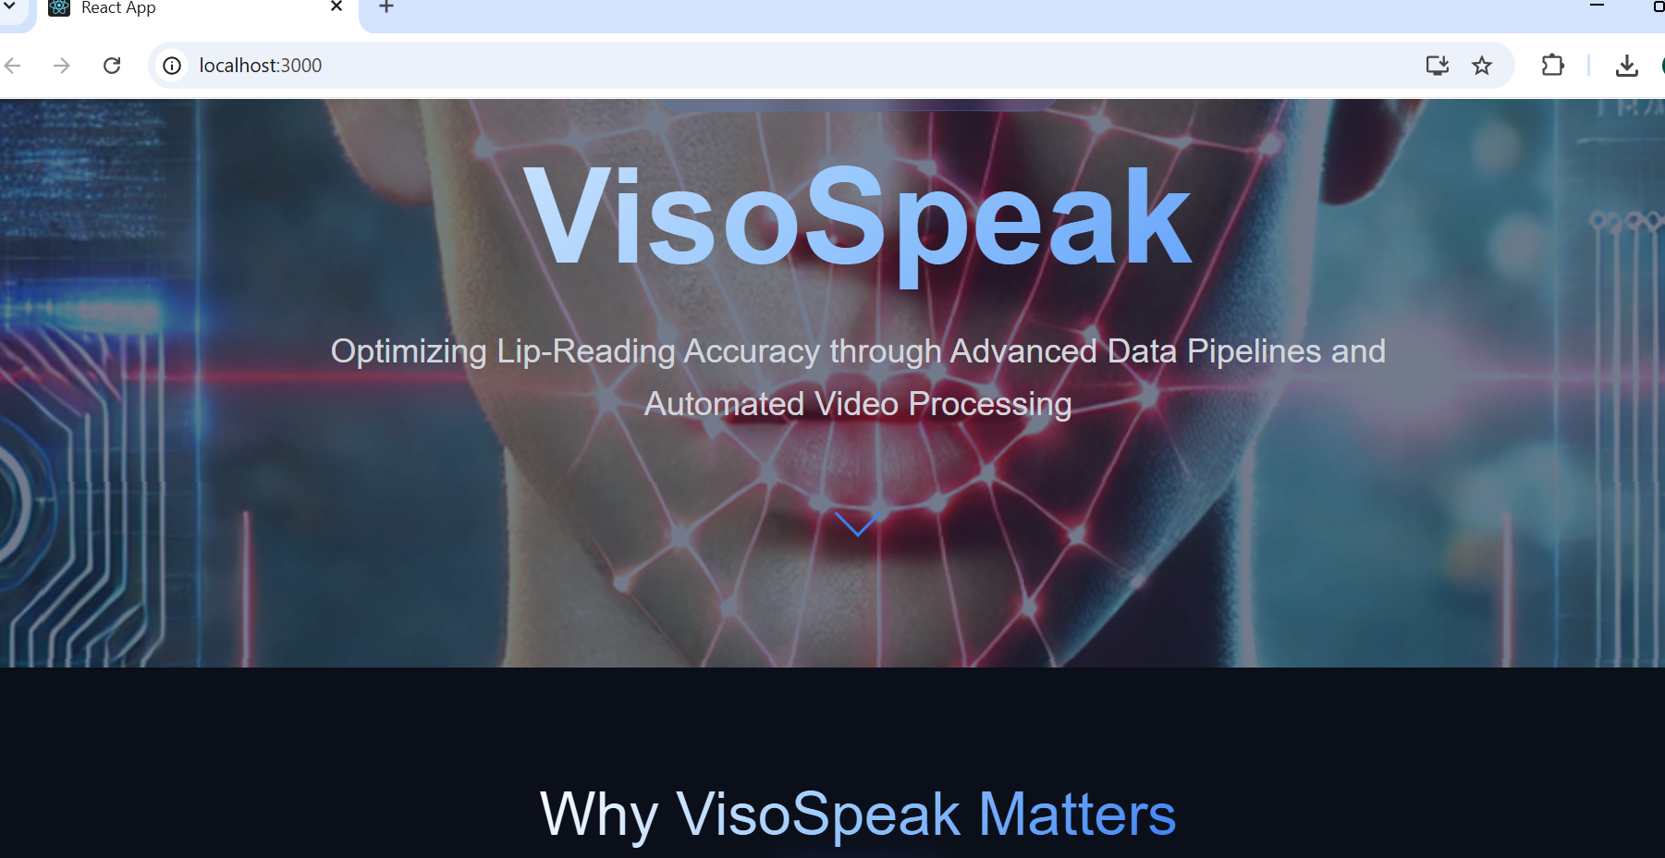
- From the homepage, select either LipNet or Transformer mode:
  - LipNet Mode – Predicts a complete sentence directly.
  - Transformer Mode – Predicts a viseme sequence with boundary accuracy visualization.
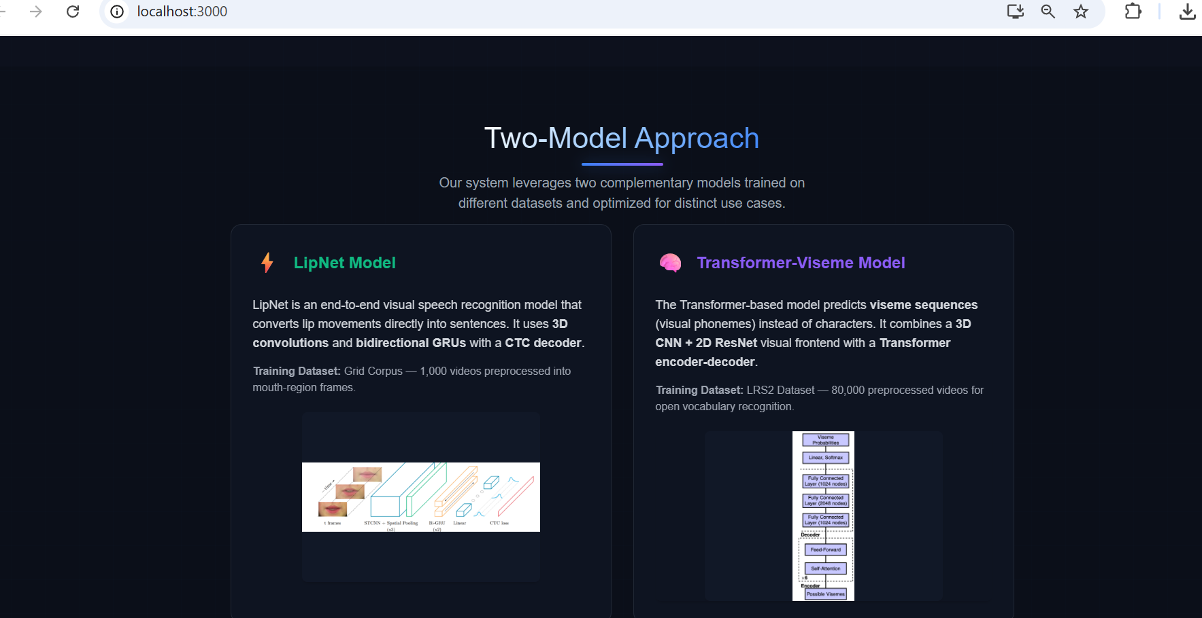

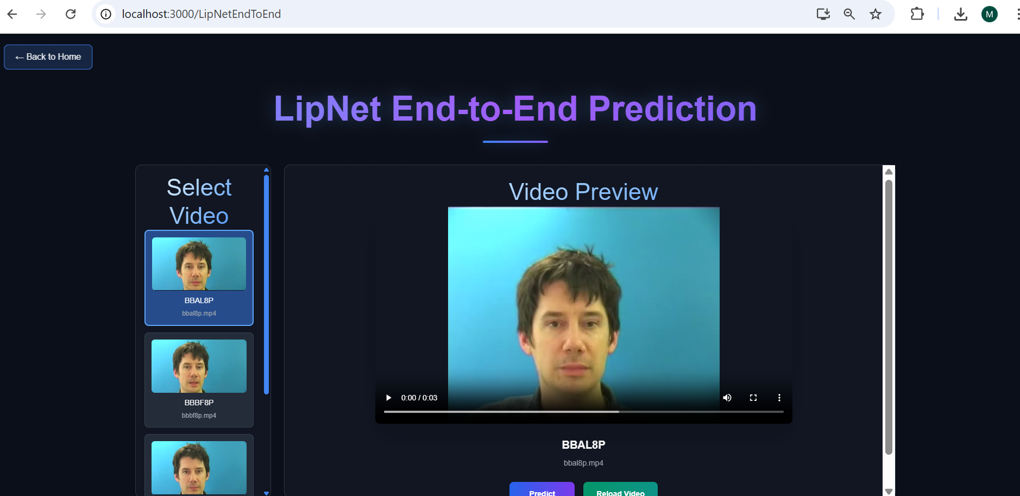
- Select a silent .mp4 video from the preloaded dataset list provided on the interface (no upload required).
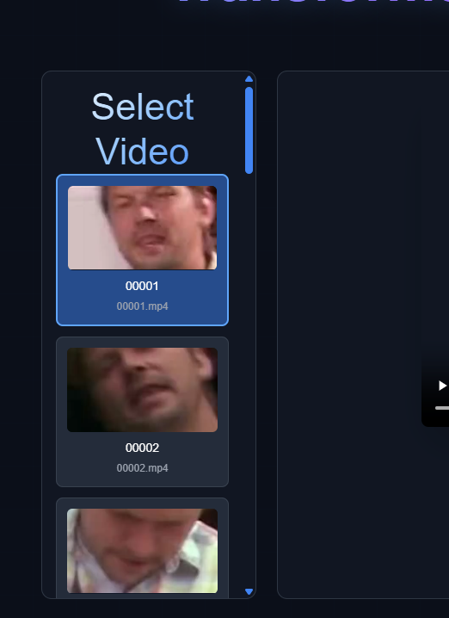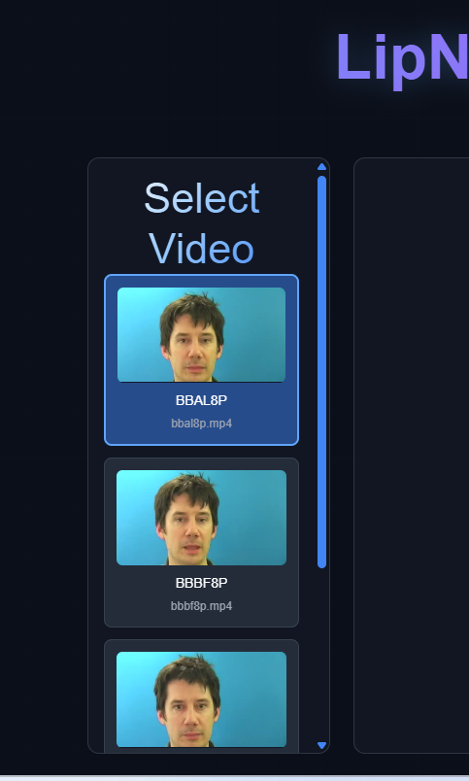
- Press Predict

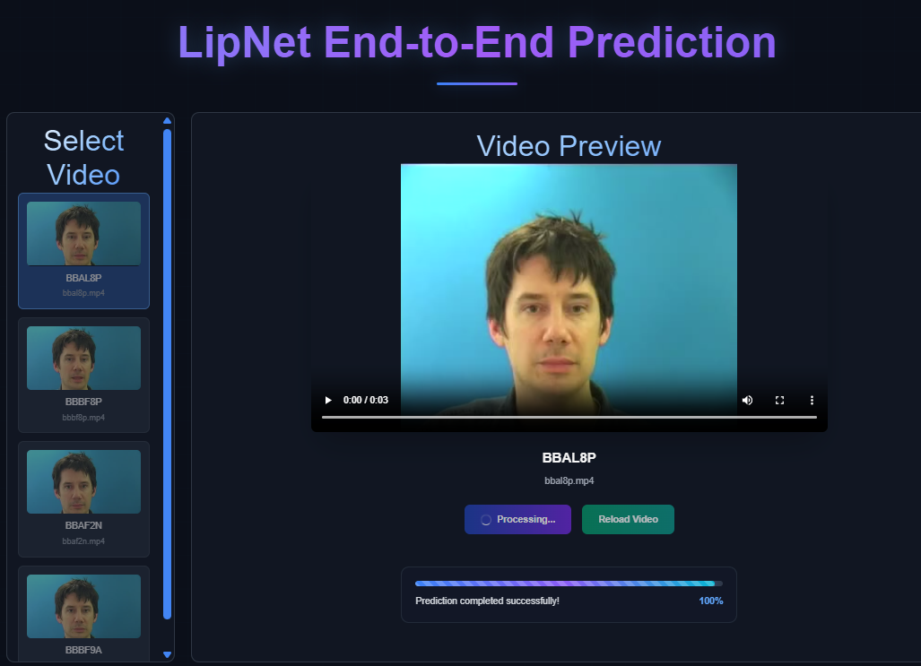
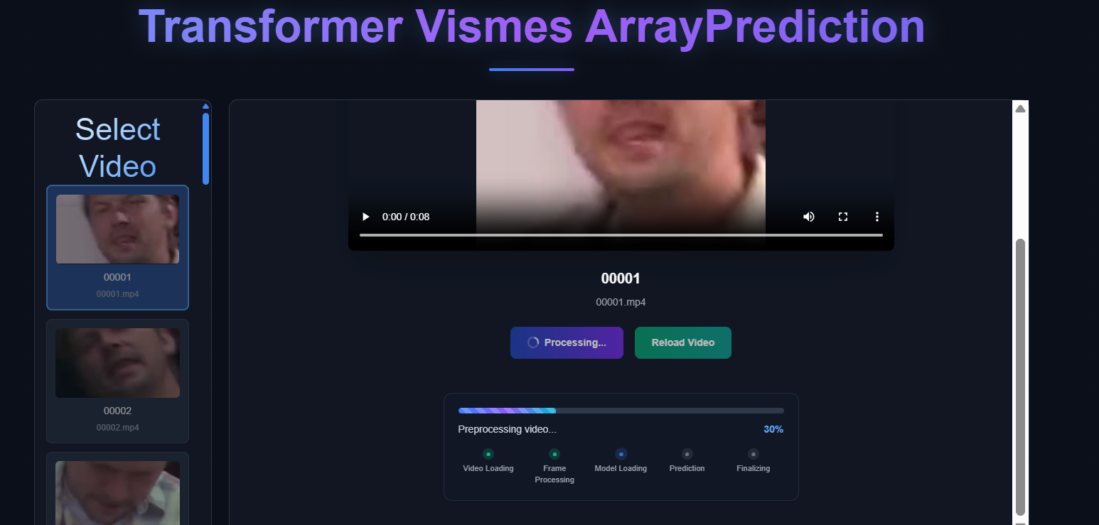
- View Prediction results
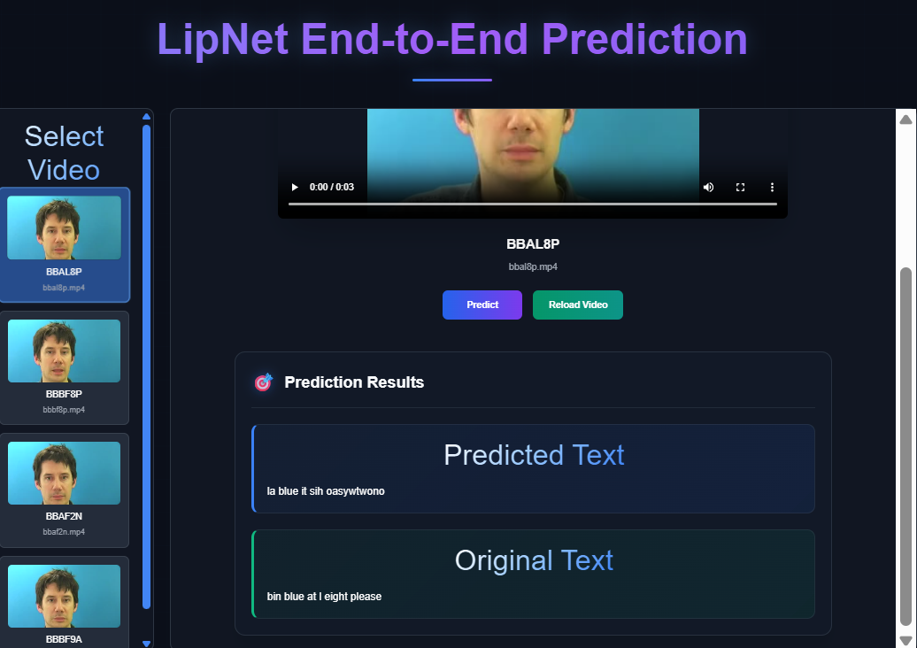
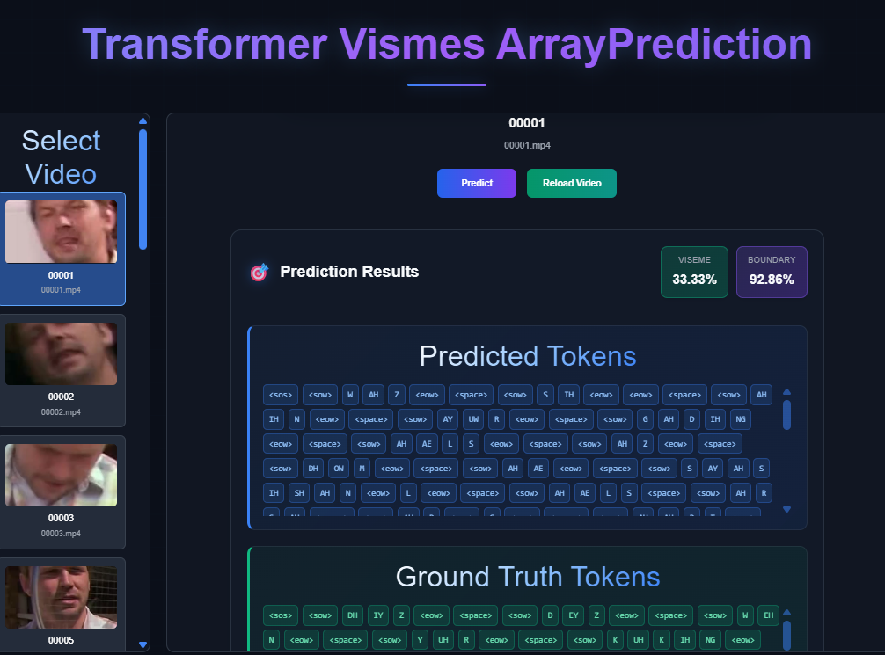
- To test another video, simply select a different video from the list.
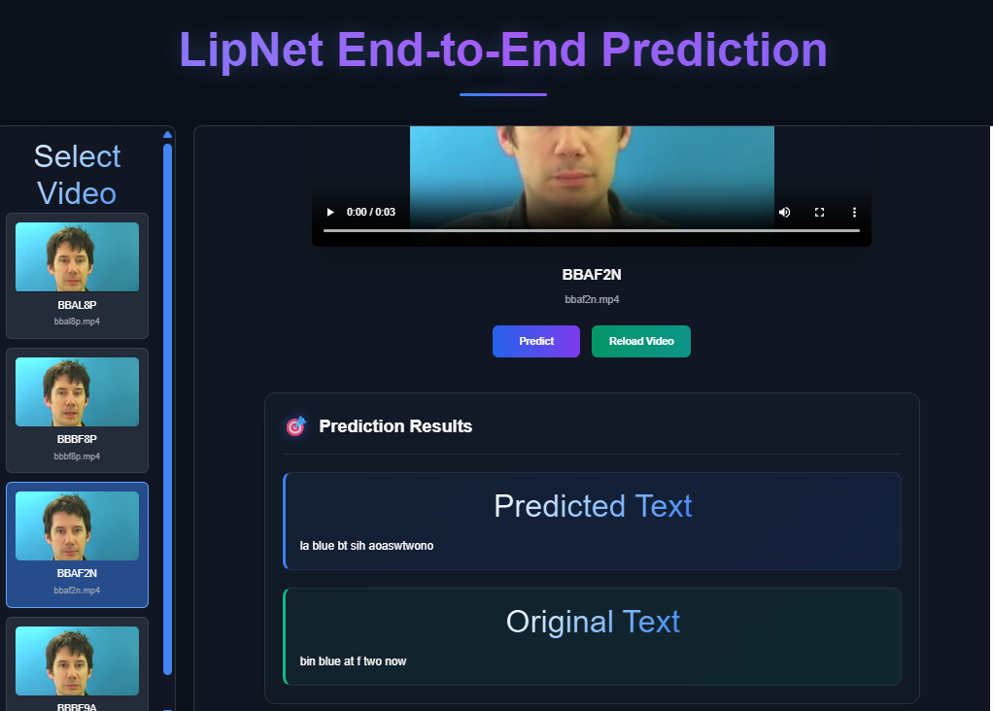
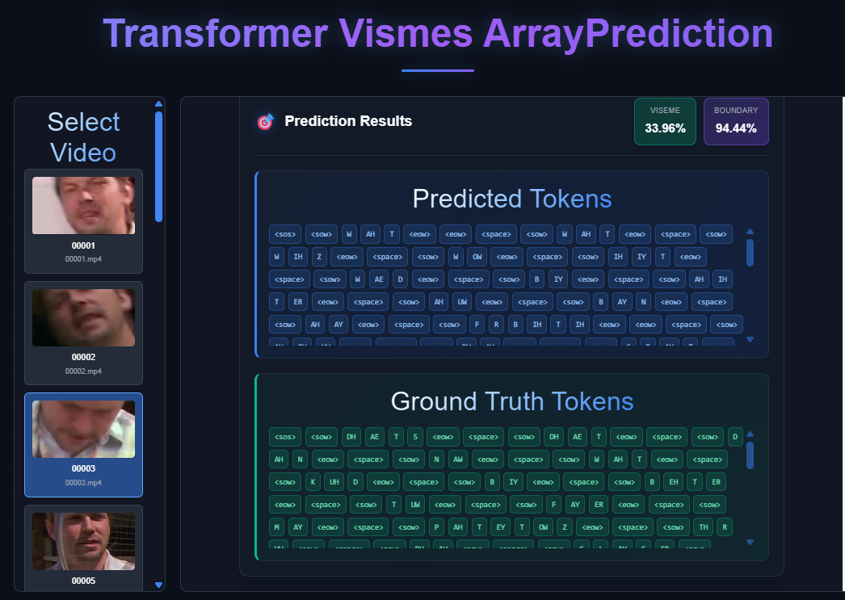

. Maintenance Guide

System architecture
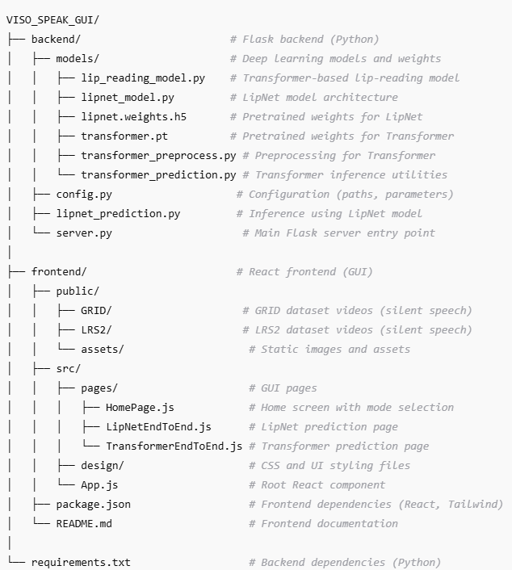

System Environment
Hardware Requirements
- GPU: At least 15 GB VRAM (NVIDIA L4, A100, or RTX 3090/4090).
- RAM: Minimum 32 GB system memory (higher is better for dataset preloading).
- Storage:
  - Uncompressed preprocessed data in .pt format: ~1.2 TB for 80,000 videos.
  - Compressed .npz batches: ~400 GB for the same dataset.
- CPU: Multi-core processor for parallel preprocessing (8+ cores recommended).

Software Dependencies
- Python 3.10+
- Core Libraries: torch, torchvision, tensorflow, keras
- Video/Audio Processing: opencv-python, mediapipe, librosa
- Data Handling: numpy, pandas, scipy
- Web API: Flask, flask-cors
- Visualization/Testing: matplotlib, seaborn, jiwer, tqdm
- Frontend: React + Tailwind (managed separately via package.json)
Full dependency list is maintained in requirements.txt (backend) and package.json (frontend)

Installation
Backend Setup
Cd backend
pip install -r requirements.txt
python server.py
Frontend Setup
cd frontend
npm install
npm start

Model Setup
Download and place the pretrained models in the correct locations:
LipNet Model:
- Download lipnet.weights.h5
- Place in: backend/models/lipnet.weights.h5
Transformer Model:
- Download the latest transformer.pt checkpoint
- Place in: backend/models/transformer.pt

Dataset

Dataset Overview
- Primary Dataset: LRS2 (Lip Reading Sentences 2)
  - Contains thousands of short clips of people speaking sentences.
  - Each clip has an accompanying alignment file indicating word timing.

Obtaining LRS2
- Must be requested directly from the University of Oxford via MIT’s dataset portal.
- The request involves:
  - Completing a research usage form.
  - Waiting for approval (can take days/weeks).
  - Downloading video (.mp4) and alignment (.txt) files.

Storage & Preprocessing
- Store raw dataset in Google Drive or local storage.
- Preprocessing steps:
  - Frame Extraction – Convert videos to frame sequences at 25 FPS.
  - Lip ROI Cropping – Use MediaPipe FaceMesh for accurate mouth region detection.
  - Normalization – Convert to grayscale and normalize pixel values.
  - Alignment Processing – Convert .txt alignments into viseme tokens.
  - Batch Compression – Save 32 videos per .npz file to reduce storage (~400 GB compressed vs 1.2 TB uncompressed).

Additional Notes
- Ensure compliance with LRS2 license (research only).
- The dataset can be extended with GRID or custom datasets for additional robustness.

Training Pipeline (Colab-Based)
Colab Setup
- Training script (transformer_train.ipynb) optimized for Google Colab L4/A100 GPUs:
  - Mixed precision for faster computation and lower memory usage.
  - Dynamic RAM buffer for streaming .npz batches (50 GB preload).
  - Batch size scales automatically with GPU memory.
Training Process
- Mount Google Drive and link preprocessed .npz data.
- Stream batches from Drive to RAM, then to GPU for training.
- Train Transformer-based viseme prediction model:
  - Encoder-Decoder architecture.
  - Input: (T, 112, 112, 1) video tensors.
  - Output: viseme sequence with boundary markers.
- Save model checkpoints (epoch_X.pt) to Drive after each epoch.
Current Training Status
- Trained on ~80,000 videos (subset due to financial limits).
- Storage usage:
  - ~1.2 TB uncompressed (.pt)
  - ~400 GB compressed (.npz)
Future Training Recommendations
- Train on the full LRS2 dataset (or augment with others) for better accuracy.
- Use higher VRAM GPUs (e.g., A100 or H100) for large-scale training.
Improving Accuracy (Future Enhancements)
Word-Level and Sentence-Level Accuracy
- Current focus: viseme prediction and boundary detection.
- Proposed improvements:
  - Fuzzy search for phoneme-to-word mapping from CMU Dictionary.
  - Replace beam search with GPT-4o or similar NLP for:
    - Word filtering.
    - Contextual sentence reconstruction.
    - Better handling of names and numbers.
Hybrid Model Approach
- Combine predictions from Transformer (visemes) and LipNet (sentence) using ensemble methods.

Deployment & Maintenance
Backend
- Flask API:
  - transformer_prediction.py → viseme prediction & boundary metrics.
  - lipnet_prediction.py → sentence-level prediction.
Frontend
- React GUI:
  - Preloaded dataset selection (no manual video upload).
  - Displays Transformer (visemes) vs LipNet (sentences) predictions.
Updating Models
- Retrain models with larger datasets.
- Replace weight files (transformer.pt, lipnet.weights.h5) in models/.
- Update config.py if file paths change.

Notes
- Colab is mainly used for training/preprocessing due to free GPU availability.
- For inference, only backend + frontend setup is required locally.
- Always ensure compliance with dataset usage policies.

Using the Application
- Open your browser and navigate to http://localhost:3000 after starting both backend and frontend servers.

References

[1] | A. S. O. V. A. Z. Joon Son Chung, "Lip Reading Sentences in the Wild," in IEEE Conference on Computer Vision and Pattern Recognition, 2017.
[2] | D. C. K. G. P. X. Souheil Fenghour, "Lip Reading Sentences Using Deep Learning With Only Visual Cues," 2020.
[3] | B. S. S. W. N. d. F. Yannis Assael, "LipNet: Sentence-Level Lipreading," 2016.
[4] | X. Z. S. R. J. S. Kaiming He, "Deep Residual Learning for Image Recognition," in IEEE Conference on Computer Vision and Pattern Recognition (CVPR), 2015.
[5] | W. X. M. Y. K. Y. Shuiwang Ji, "3D Convolutional Neural Networks for Human Action Recognition," in 27th International Conference on Machine Learning, 2010.
[6] | D. Y. Soonkyu Lee, "Audio-to-Visual Conversion Using Hidden Markov Models," in PRICAI 2002, LNAI 2417, 2002.
[7] | C. L. L. R. C. H. W. R. Sofia Lemons, " Beam Search: Faster and Monotonic," in 32nd International Conference on Automated Planning and Scheduling (ICAPS), 2022.
[8] | T. V. R. C. Clara Meister, "Best-First Beam Search," in Transactions of the Association for Computational Linguistics, 2020.
[9] | K. N. T. S. I. S. Alec Radford, " Improving Language Understanding by Generative Pre-Training," in OpenAI.
[10] | D. A. D. E. C. S. S. R. C.-Y. F. A. C. B. Wei Liu, "SSD: Single Shot MultiBox Detector," in Lecture Notes in Computer Science, 2016.
[11] Mansimran Kaur 1, ∗, †, Dhruv Rastogi 2,† Anjali Sharma 3,†, Anushka Dahiya 4,†, Preeti Nagrath , "Crime Investigation Using Lip Reading"
[12] Stavros Petridis, Jie Shen, Doruk Cetin† , “ VISUAL-ONLY RECOGNITION OF NORMAL, WHISPERED AND SILENT SPEECH”
[13] https://www.python.org/
[14] https://onlinelibrary.wiley.com/doi/10.1155/2024/6479124
[15] Ritika Chandel , Rajnandini Bhowmick, U. Hariharan , “A Comparison of Face Landmark Detection Techniques”
[16] https://medium.com/pythons-gurus/what-is-the-best-face-detector-ab650d8c1225
[17] Panca Mudjirahardjo*, Aqil Gama Rahmansyah*, Alya Shafa Dianti**, “The Performance of Color and Grayscale Image Input in Convolutional Neural Network based Head Detection”
[18] Yang Shen ¹, Julia Wang ², Saket Navlakha ³ ,”A Correspondence Between Normalization Strategies in Artificial and Biological Neural Networks”
[19] https://en.wikipedia.org/wiki/Normalization_%28machine_learning%29
[18] https://pmc.ncbi.nlm.nih.gov/articles/PMC8662716/
[19] https://en.wikipedia.org/wiki/Normalization_%28machine_learning%29
[20] Lei Zhao, Zhonglin Zhang, “A improved pooling method for convolutional neural networks”

